Edward Bell April 19, 2016

Director of Housekeeping
Hilton Oakbrook Hills Resort
3500 Midwest Rd.
Oakbrook, IL 60522

Email: ebell@destinationhotels.com

Dear Mr. Bell:

Thank you very much for the opportunity to once again earn your business. We are pleased to present you this proposal for the deep restoration cleaning of your draperies. If you have any questions regarding my proposal, please do not hesitate to call me.

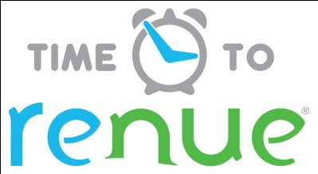

Why choose Renue Systems for your deep cleaning needs?

- We are the leading provider of comprehensive deep cleaning services exclusively to the hospitality industry – we have proudly serviced thousands of hotels over our 30 year history
- We are the only company that has been a North America approved vendor of Avendra since its formation
- Expertly trained, certified and uniformed employees that specialize in working in the hotel environment – no micromanaging of our team by your team is needed
- Proprietary equipment and chemicals, well-tested methodologies and significant ongoing R&D to provide top results
- Extremely responsive scheduling and highly flexible payment plans to meet your changing needs – we work when it is convenient to you and on a 24/7 basis
- Easy to understand and transparent pricing – and all our work is 100% guaranteed to your satisfaction

At your property we will perform the following methodology, a well-tested technique we have developed over the years in conjunction with the leading deep floorcare cleaning association and the largest floorcare manufacturers:

Our deep clean process-

Step #1: PRE-VACUUM all heavily soiled pleats to remove any loose soiling.

Step #2: PRE-SPRAY spotted and heavily soiled areas with cutting-edge starter detergents to accelerate soil release before the steam extraction step. All of our Venue Hygiene®Plus chemicals are formulated specifically for Renue Systems.

Step #3: STEAM EXTRACTION using state-of-the-art portable extraction equipment, including water heater, low psi controlled solution pump and dual vacuums for maximum water recovery.

Step #3: (OPTIONAL-IF NEEDED) DRY CLEANING of drapes or sheers if there is a concern about the material shrinking with a water extraction process. The dry cleaning will be done using a special dry solvent cleaning machine and odorless mineral spirits. A determination of the best process will be made before any cleaning is to begin by your Renue technician.

Step #4: FLAME RETARDANT chemical application on all cleaned material for public draperies ONLY. A certificate of application will be provided to the hotel upon completion of cleaning. This is to be kept on file in the engineering department for the fire marshals inspection, if necessary.

Project details and costs for proposed cleaning

Service pack #1 Deep Cleaning of Draperies:

- All tent sheer cleaning from ceiling to floor…………………….$3,500.00
- Rental of each scissor lift (2 required)……………………………$

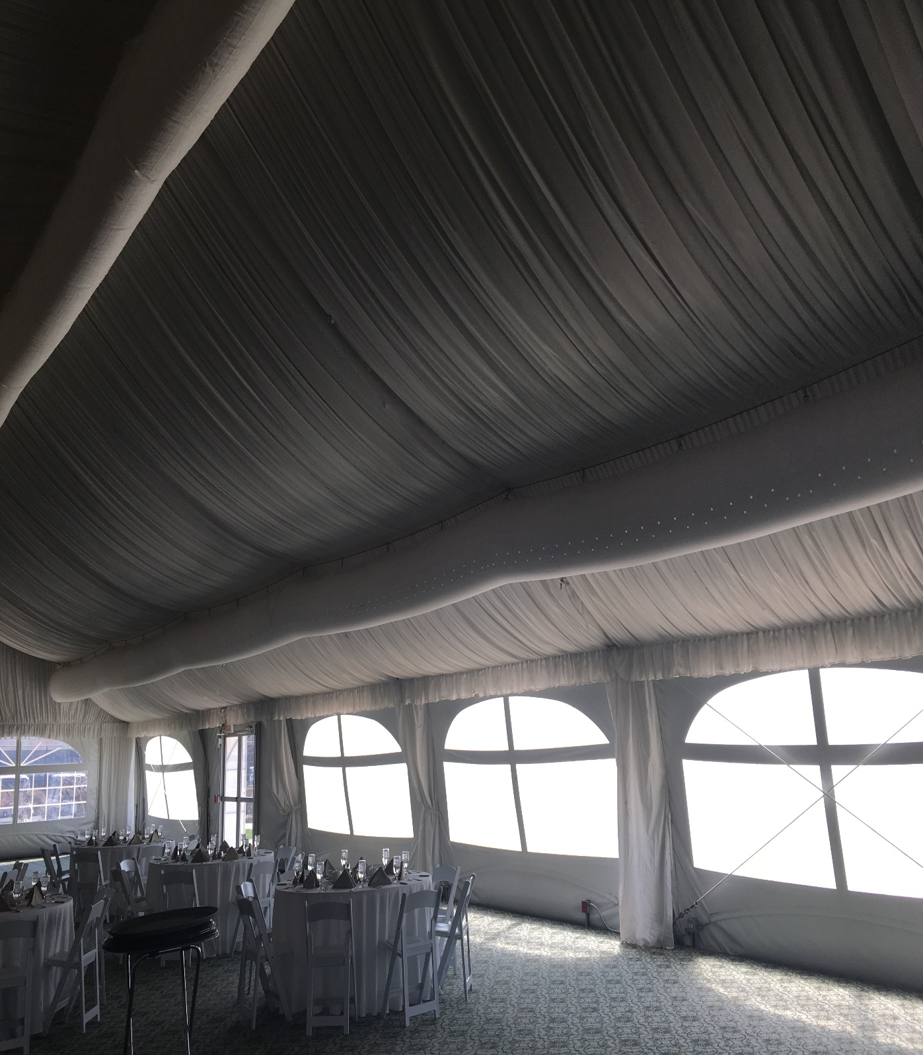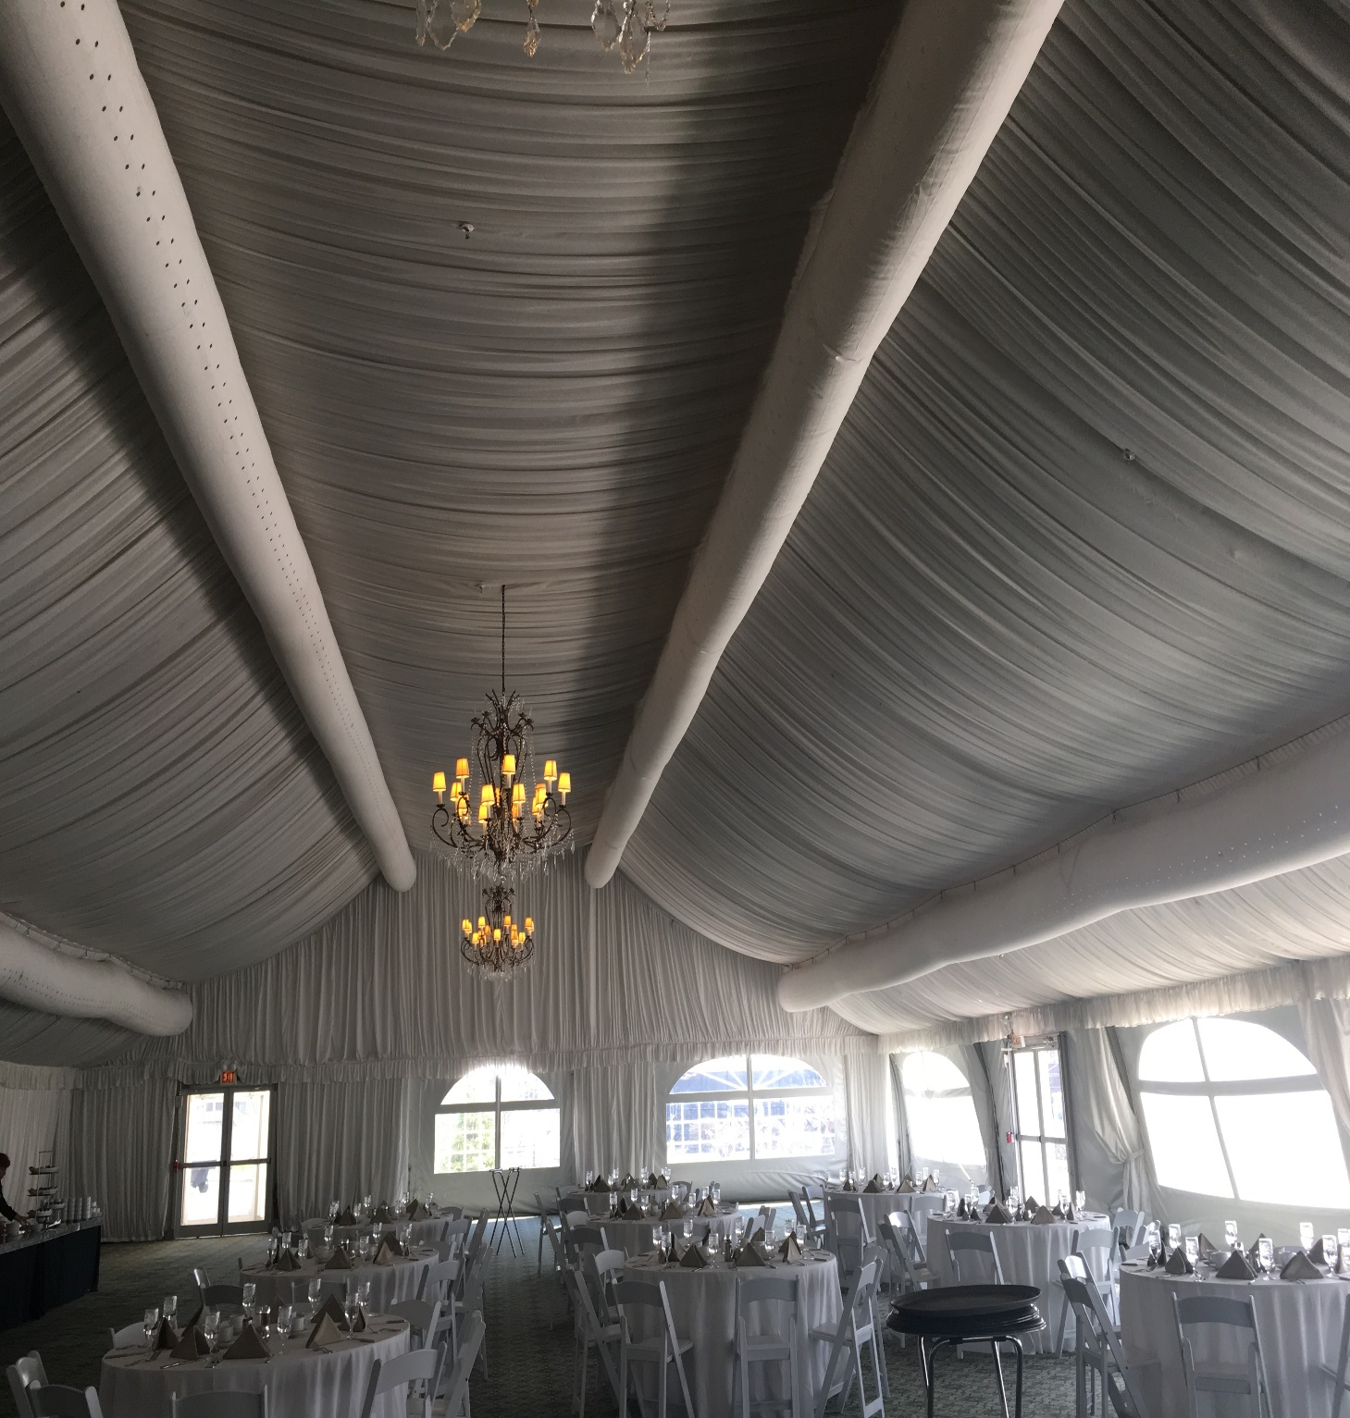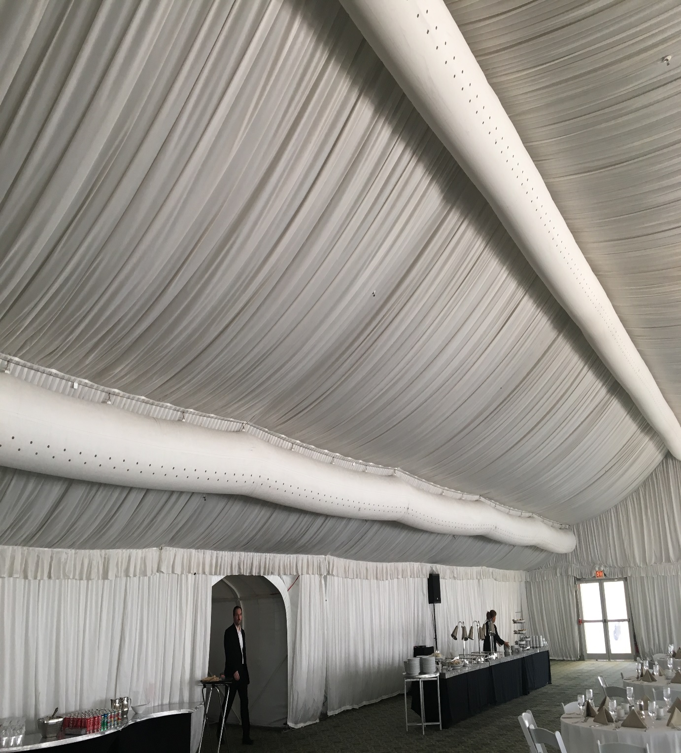

PLEASE NOTE:

*48 hour cancellation notice required or a 15% cancellation fee will be charged.

*Renue Systems requires a $350.00 minimum service call charge per visit. This is NOT in addition to any scheduled work.

*Hotel will provide complimentary parking during any scheduled work or cost will be billed back to the hotel.

*Hotel will provide access to guestrooms in a contiguous fashion to Renue System technicians during scheduled cleaning.

*All work must be scheduled on a single ticketed work order and finished within a set amount of days.

Note some staining in the drapery and sheer fibers may be permanent and not removable with cleaning

We will be glad to afford you payment terms to work within your budget

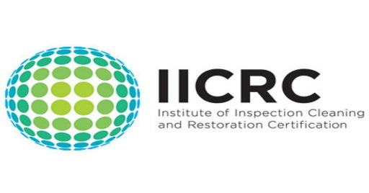
Hilton Supply Management

Please complete this service agreement, sign it and return it to your local Renue Systems service provider.

Scope of Service:

Description: ________________________________________________________________
______________________________________________________________________________

Payment Terms:

The sum of $________________ is the agreed upon price for the services rendered with payment to made as follows:

____________ payments each for $___________ according to the following schedule:
______________________________________________________________________________

Please check here if your property will be paying by P-Card ___ or check ___

Card # _________________________ Card type _________________ Exp. date __________

3 Digit Security Code (back of card)____________________

We reserve the right to charge a credit card fee for a project paid by credit card exceeding $10,000

Acceptance of Service Agreement

The above pricing, specifications, terms and conditions are satisfactory and you are hereby authorized to commence the work as specified.

Name: _______________________________________________ Property:__________________________________

Signature: ____________________________________________ P.O. # (if needed):___________________________

Title: ________________________________________________ Date: _____________________________________

Phone: _______________________________________________ Email: ____________________________________

