David Grossman September 16, 2016
Director of Operation
Taj Mahal
Agra, Uttar Pradesh
282001, India

Email:

Dear David-

We are pleased to present you this proposal for the deep restoration of your treated wood floors in the 2nd floor restaurant and lounge areas on a quarterly basis. After examining your property, reviewing the manufactures maintenance guidelines and discussing your needs, I have prepared the service outline below.

Why choose Renue Systems for your deep cleaning needs?

- We are the leading provider of comprehensive deep cleaning services exclusively to the hospitality industry – we have proudly serviced thousands of hotels over our 30 year history
- We are the only company that has been a North America approved vendor of Avendra since its formation
- Expertly trained, certified and uniformed employees that specialize in working in the hotel environment – no micromanaging of our team by your team is needed
- Proprietary equipment and chemicals, well-tested methodologies and significant ongoing R&D to provide top results
- Extremely responsive scheduling and highly flexible payment plans to meet your changing needs – we work when it is convenient to you and on a 24/7 basis
- Easy to understand and transparent pricing – and all our work is 100% guaranteed to your satisfaction

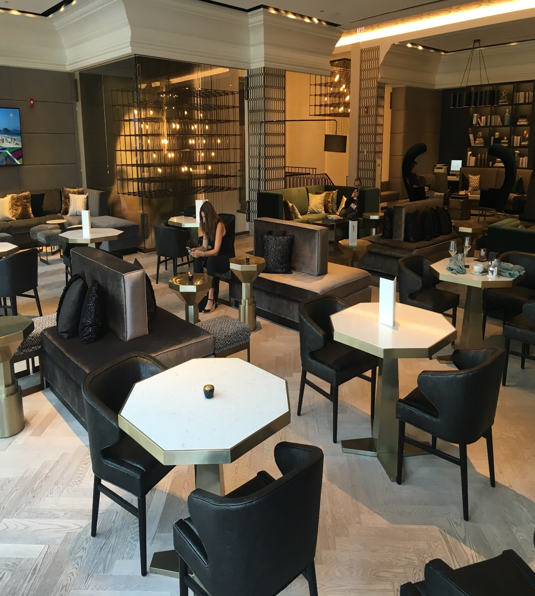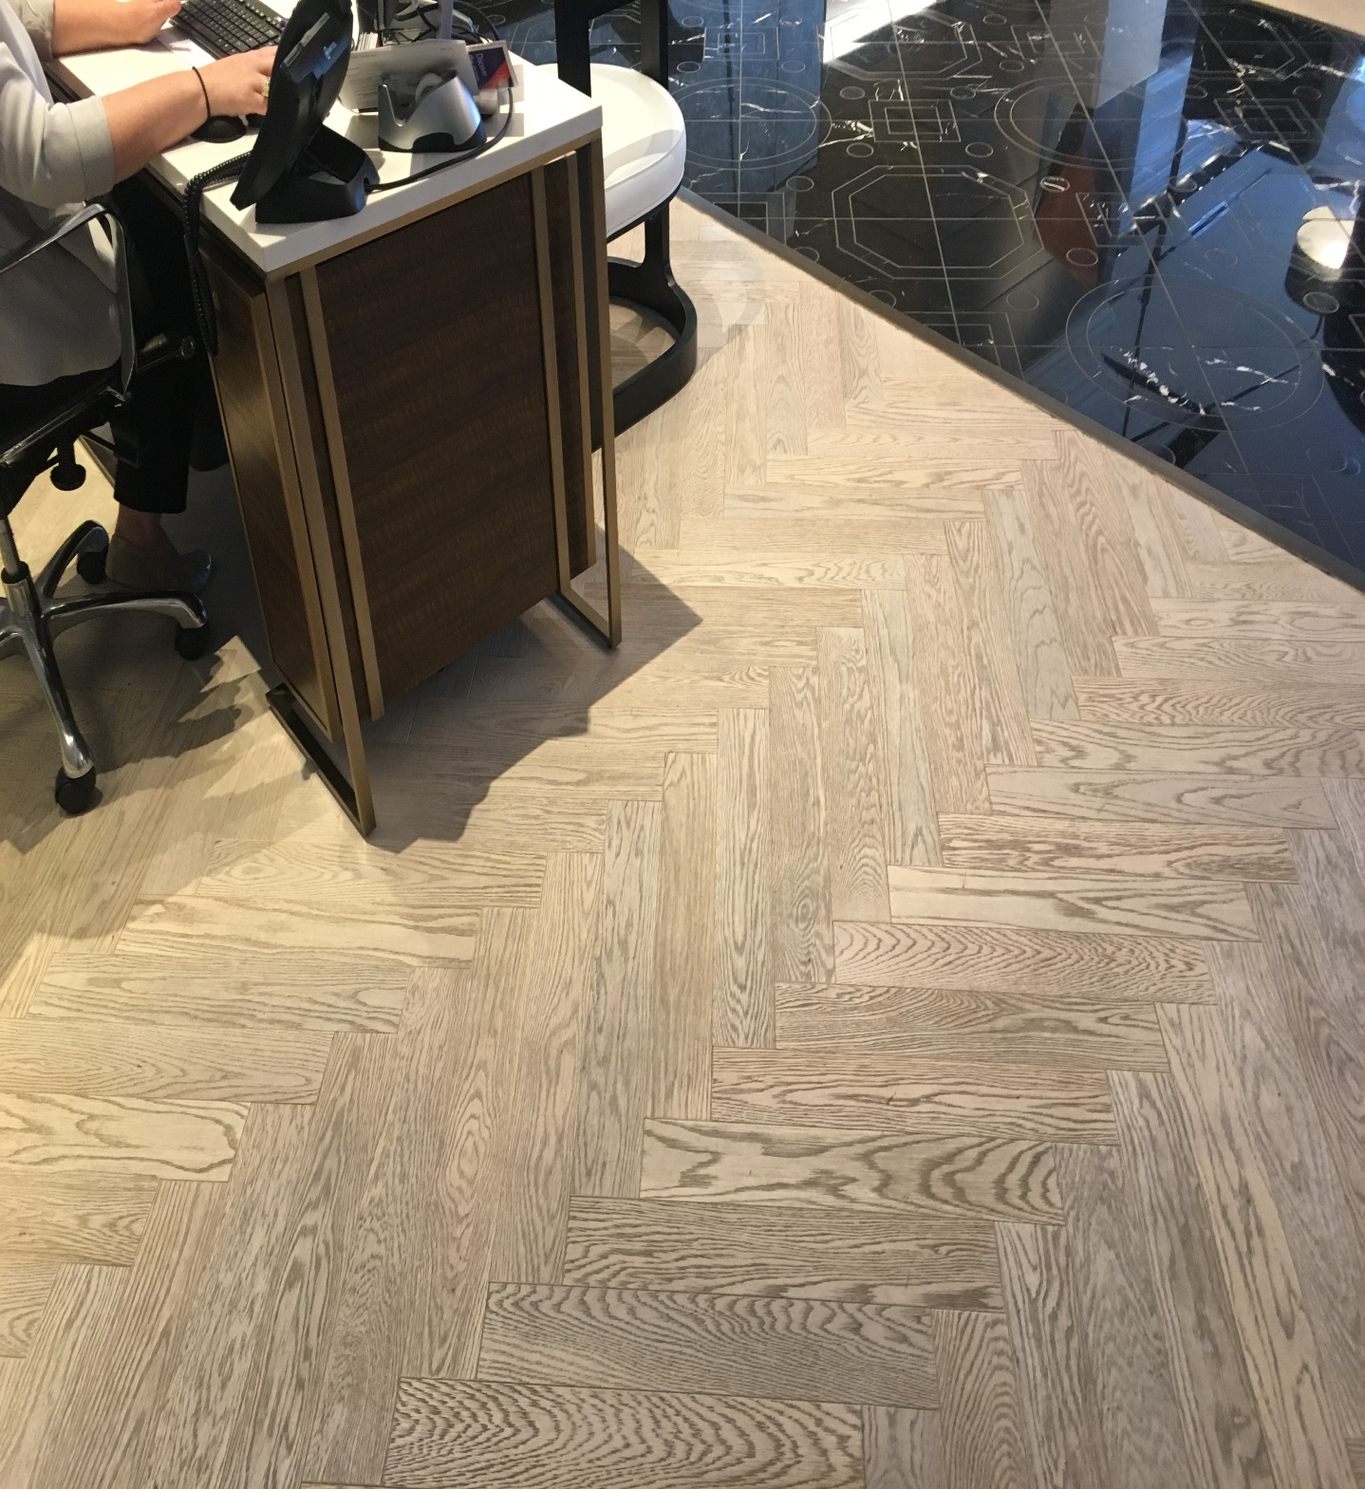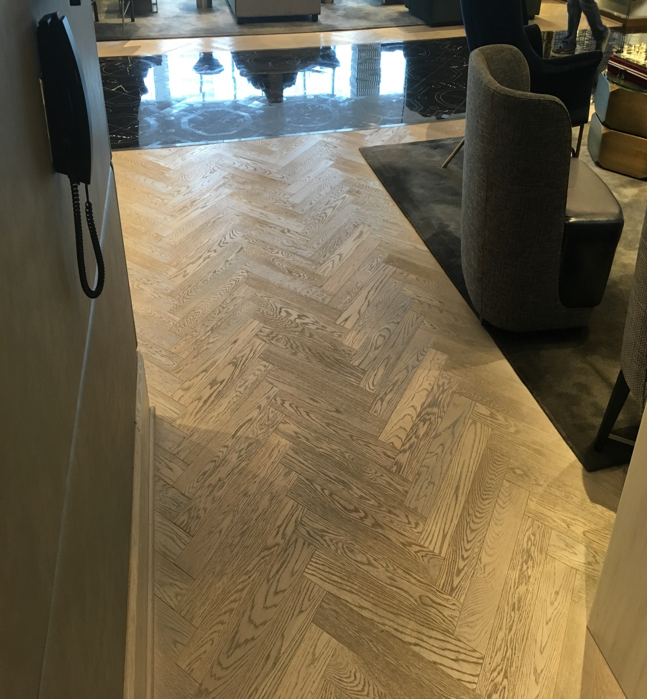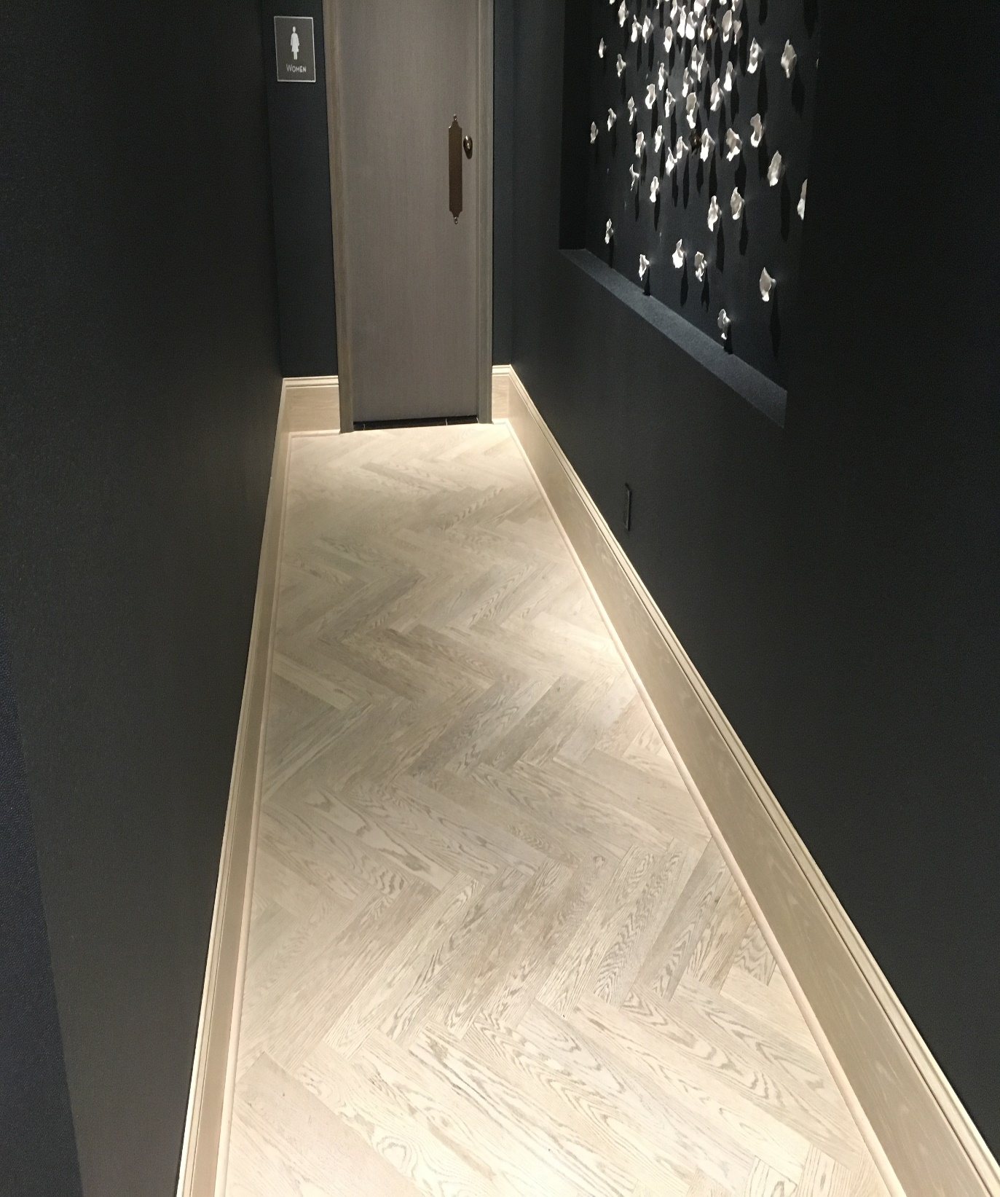
At your property we will perform the following methodology, a well-tested technique we have developed over the years in conjunction with the leading deep floorcare cleaning association and the largest floorcare manufacturers:

Our deep clean process-

Renue’s Rapid Venue Restoration

Step #1: Clean and scrub all floors with a 175 rpm rotary machine using a standard white scrub pad and Bona Deep Clean Solution recommended by the manufacturer of this flooring.

Step #:2 Mop all floors to remove dirty slurry from the above.

Step #:3 Dry all floors with a 1500 cfm air movers.

Step #:4 Buff all floors with a Melamine white pad.

Project details and costs for proposed cleaning

Areas: 1841 total square feet

Second floor laminate wood in lounge/restaurant areas, around front desk, concierge desk & in hall leading to bathrooms. Move any furniture and replace.

Does not include flooring under area rugs

Cost for deep cleaning quarterly (4x’s per year)…………………………$6,500.00

PLEASE NOTE

Renue Systems will not be responsible for the following:

- Scratched, chipped or cracked floor planks
- Flooring where the integrity of the tile has been compromised over the years
- Some staining or shading may be permanent in vinyl and not removed with restoration
- Pricing does NOT include cleaning of cove base

*48 hour cancellation notice required or a 15% cancellation fee will be charged.

*Hotel will provide complimentary parking during scheduled service or the cost will be billed back to the hotel.

Please complete this service agreement, sign it and return it to your local Renue Systems service provider.

Scope of Service:

Description: ________________________________________________________________
______________________________________________________________________________

Payment Terms:

The sum of $________________ is the agreed upon price for the services rendered with payment to made as follows:

____________ payments each for $___________ according to the following schedule:
______________________________________________________________________________

Please check here if your property will be paying by P-Card ___ or credit card ___

Card # _________________________ Card type _________________ Exp. date __________

Acceptance of Service Agreement

The above pricing, specifications, terms and conditions are satisfactory and you are hereby authorized to commence the work as specified.

Name: _______________________________________________ Property:__________________________________

Signature: ____________________________________________ P.O. # (if needed):___________________________

Title: ________________________________________________ Date: _____________________________________

Phone: _______________________________________________ Email: ____________________________________

