Mr. John Junior July 18, 2017
Executive Chef

Hyatt Regency Schaumburg
1800 E. Golf Rd
Schaumburg, IL.

E mail: john.junior@hyatt.com

Dear John:

Thank you very much for the opportunity to earn your business. We are pleased to present you this proposal for the deep restoration cleaning of your tile and grout. If you have any questions regarding my proposal, please do not hesitate to call me.

Why choose Renue Systems for your deep cleaning needs?

- We are the leading provider of comprehensive deep cleaning services exclusively to the hospitality industry – we have proudly serviced thousands of hotels over our 30 year history
- We are the only company that has been a North America approved vendor of Avendra since its formation
- Expertly trained, certified and uniformed employees that specialize in working in the hotel environment – no micromanaging of our team by your team is needed
- Proprietary equipment and chemicals, well-tested methodologies and significant ongoing R&D to provide top results
- Extremely responsive scheduling and highly flexible payment plans to meet your changing needs – we work when it is convenient to you and on a 24/7 basis
- Easy to understand and transparent pricing – and all our work is 100% guaranteed to your satisfaction

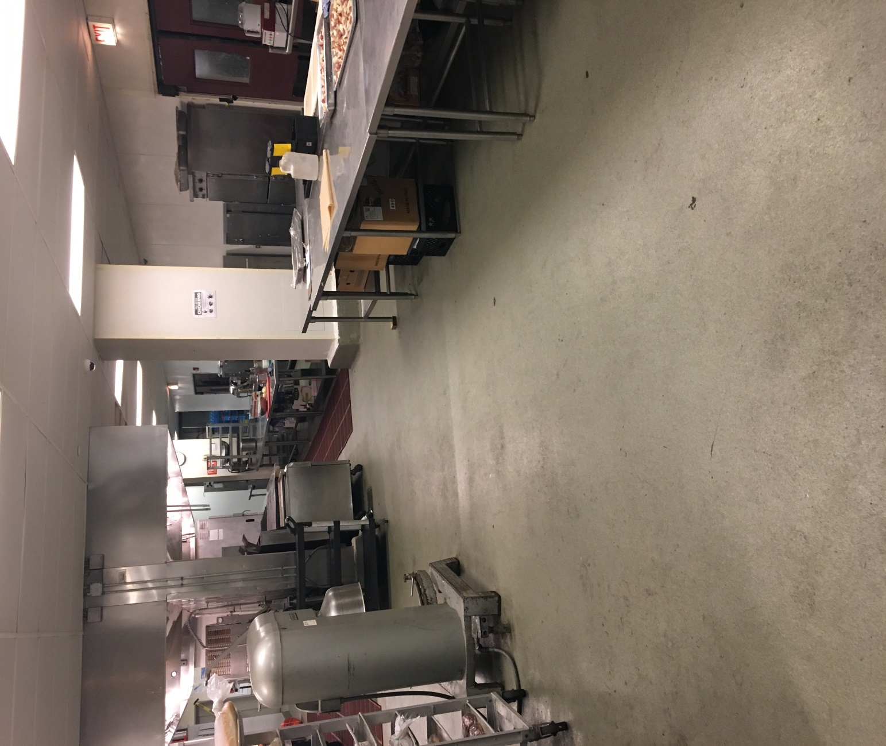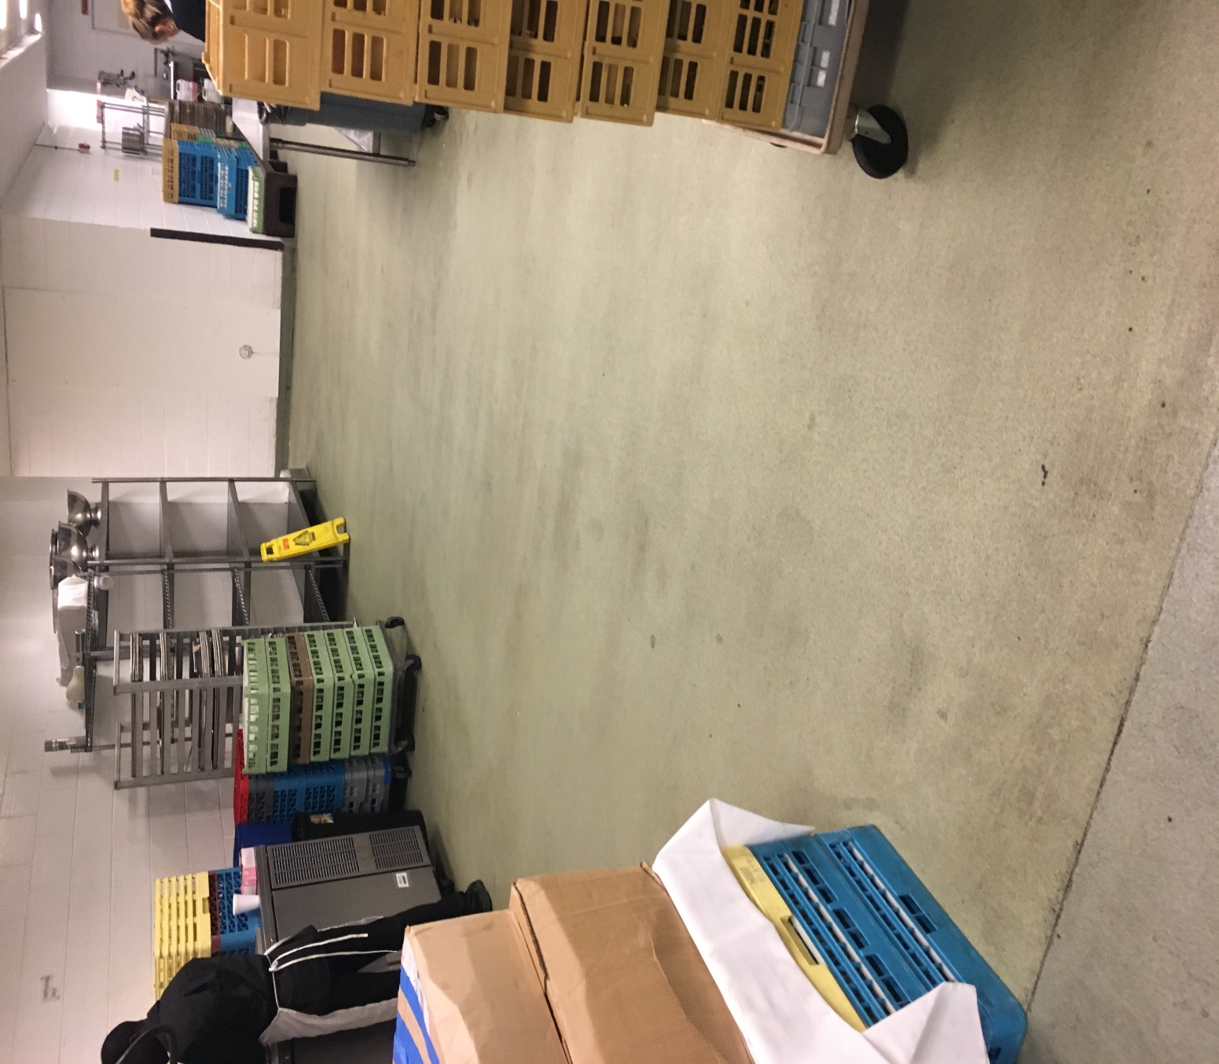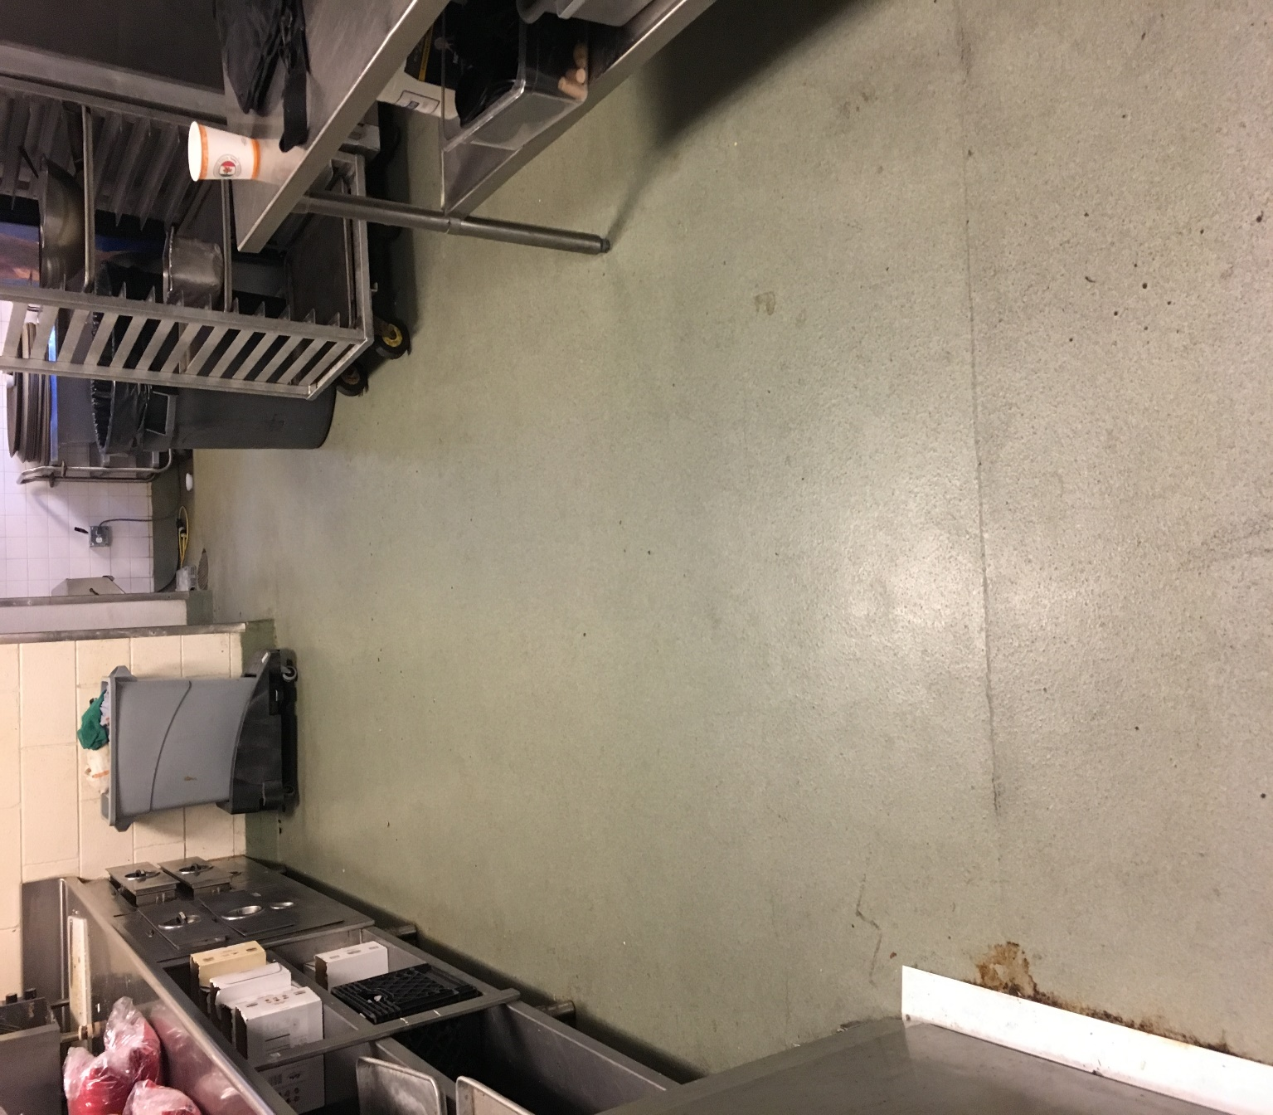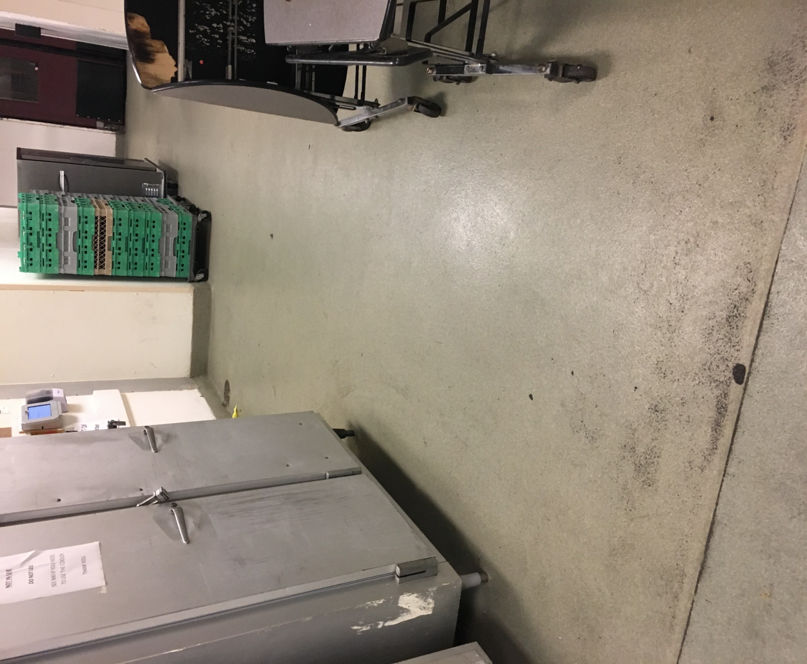

At your property we will perform the following methodology, a well-tested technique we have developed over the years in conjunction with the leading deep floorcare cleaning association and the largest floorcare manufacturers:

Our deep clean process-

Step #1: Pre-Spray epoxy floor with alkaline detergent to loosen soiling and enhance appearance of the grout lines. All of our Hotel Hygiene® Plus chemicals are formulated specifically for Renue Systems.

Step #2: Power Wash epoxy flooring using our state-of-the-art rotary truck mount cleaning unit delivering 1600psi of 250 degree hot water in conjunction with cutting-edge starter detergents to accelerate soil release.

Project details and costs for proposed cleaning

Service pack #1 Epoxy Floor Deep Cleaning:

- All epoxy flooring in kitchen areas (6,136 SF)………………$2,945.28

PLEASE NOTE

Renue Systems will not be responsible for the following (but we can address):

- Compromised or missing epoxy
- Chipped or cracked areas in the epoxy floor
- Areas that have been painted and are not the original color
- Uneven surface coloring and cracks may be evident after floor is cleaned and free of dirt and grease
- Some staining may be permanent in the epoxy coating

*Some staining in the epoxy may be permanent and not removable with cleaning.

*48 hour cancellation notice required or a 15% cancellation fee will be charged.

*Hotel will provide complimentary parking during any scheduled work or cost will be billed back to the hotel.

We will be glad to afford you payment terms to work within your budget
APPROVED VENDOR

Please complete this service agreement, sign it and return it to your local Renue Systems service provider.

Scope of Service:

Description: ________________________________________________________________
______________________________________________________________________________

Payment Terms:

The sum of $________________ is the agreed upon price for the services rendered with payment to made as follows:

____________ payments each for $___________ according to the following schedule:
______________________________________________________________________________

Please check here if your property will be paying by P-Card ___ or check ___

Card # _________________________ Card type _________________ Exp. date __________

3 Digit Security Code (back of card)____________________

Acceptance of Service Agreement

The above pricing, specifications, terms and conditions are satisfactory and you are hereby authorized to commence the work as specified.

Name: _______________________________________________ Property:__________________________________

Signature: ____________________________________________ P.O. # (if needed):___________________________

Title: ________________________________________________ Date: _____________________________________

Phone: _______________________________________________ Email: ____________________________________

