Jolyn Hernandez October 15, 2019
Executive Housekeeper
Hilton Suites Chicago/Magnificent Mile
198 E. Delaware Place
Chicago, IL 60611

Email: Jolyn.Hernandez@hilton.com

Dear Jolyn:

Thank you very much for the opportunity to once again earn your business. We are pleased to present you this proposal for the deep restoration cleaning of your rubber gym tiles. If you have any questions regarding my proposal, please do not hesitate to call me.

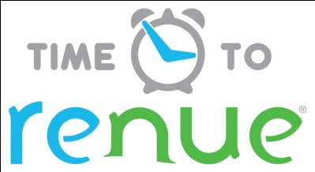

Why choose Renue Systems for your deep cleaning needs?

- We are the leading provider of comprehensive deep cleaning services exclusively to the hospitality industry – we have proudly serviced thousands of hotels over our 30 year history
- We are the only company that has been a North America approved vendor of Avendra since its formation
- Expertly trained, certified and uniformed employees that specialize in working in the hotel environment – no micromanaging of our team by your team is needed
- Proprietary equipment and chemicals, well-tested methodologies and significant ongoing R&D to provide top results
- Extremely responsive scheduling and highly flexible payment plans to meet your changing needs – we work when it is convenient to you and on a 24/7 basis
- Easy to understand and transparent pricing – and all our work is 100% guaranteed to your satisfaction

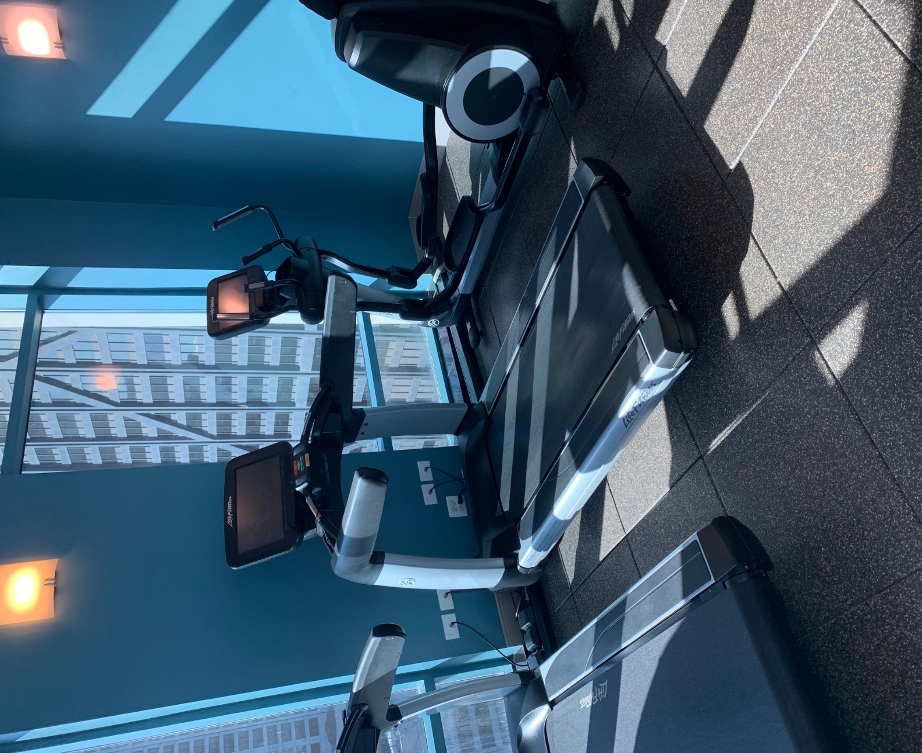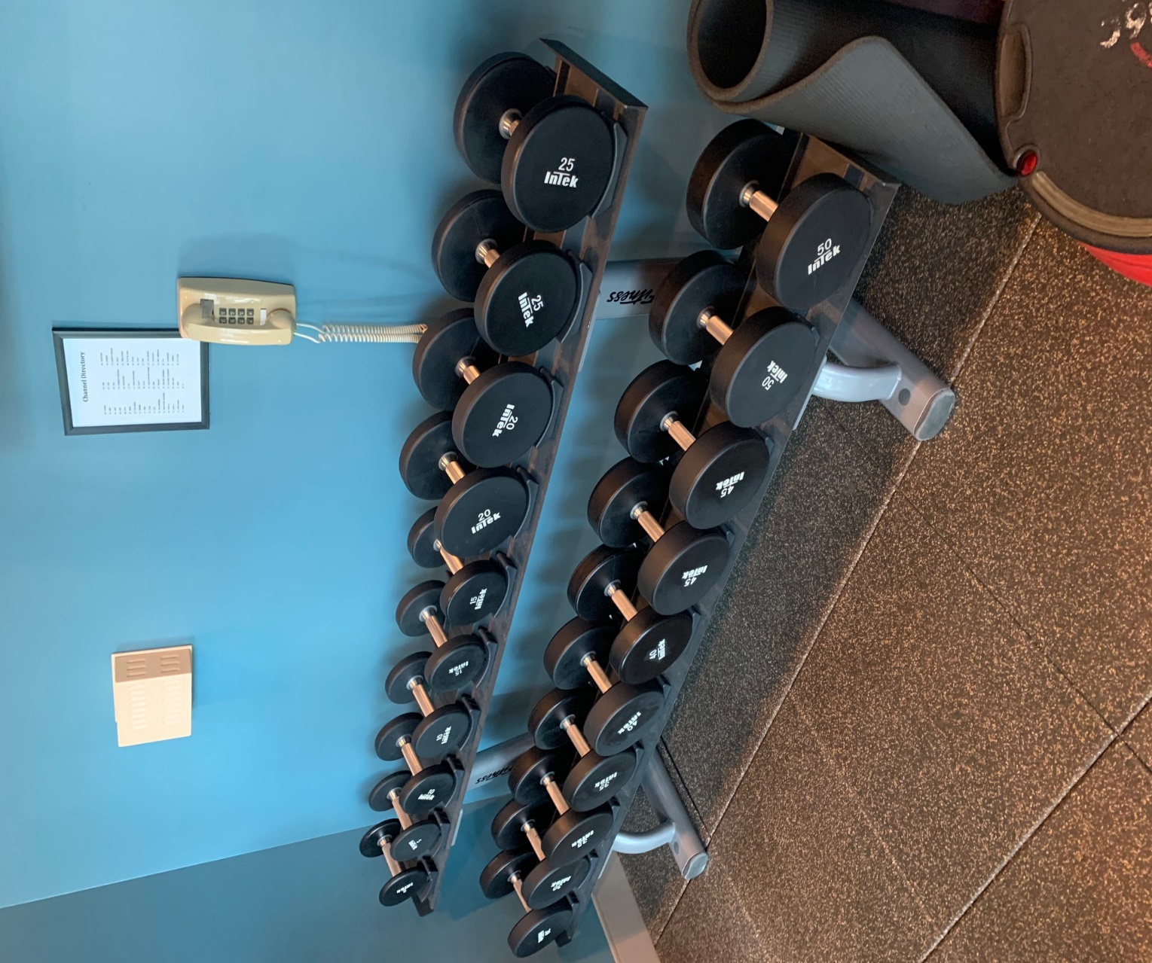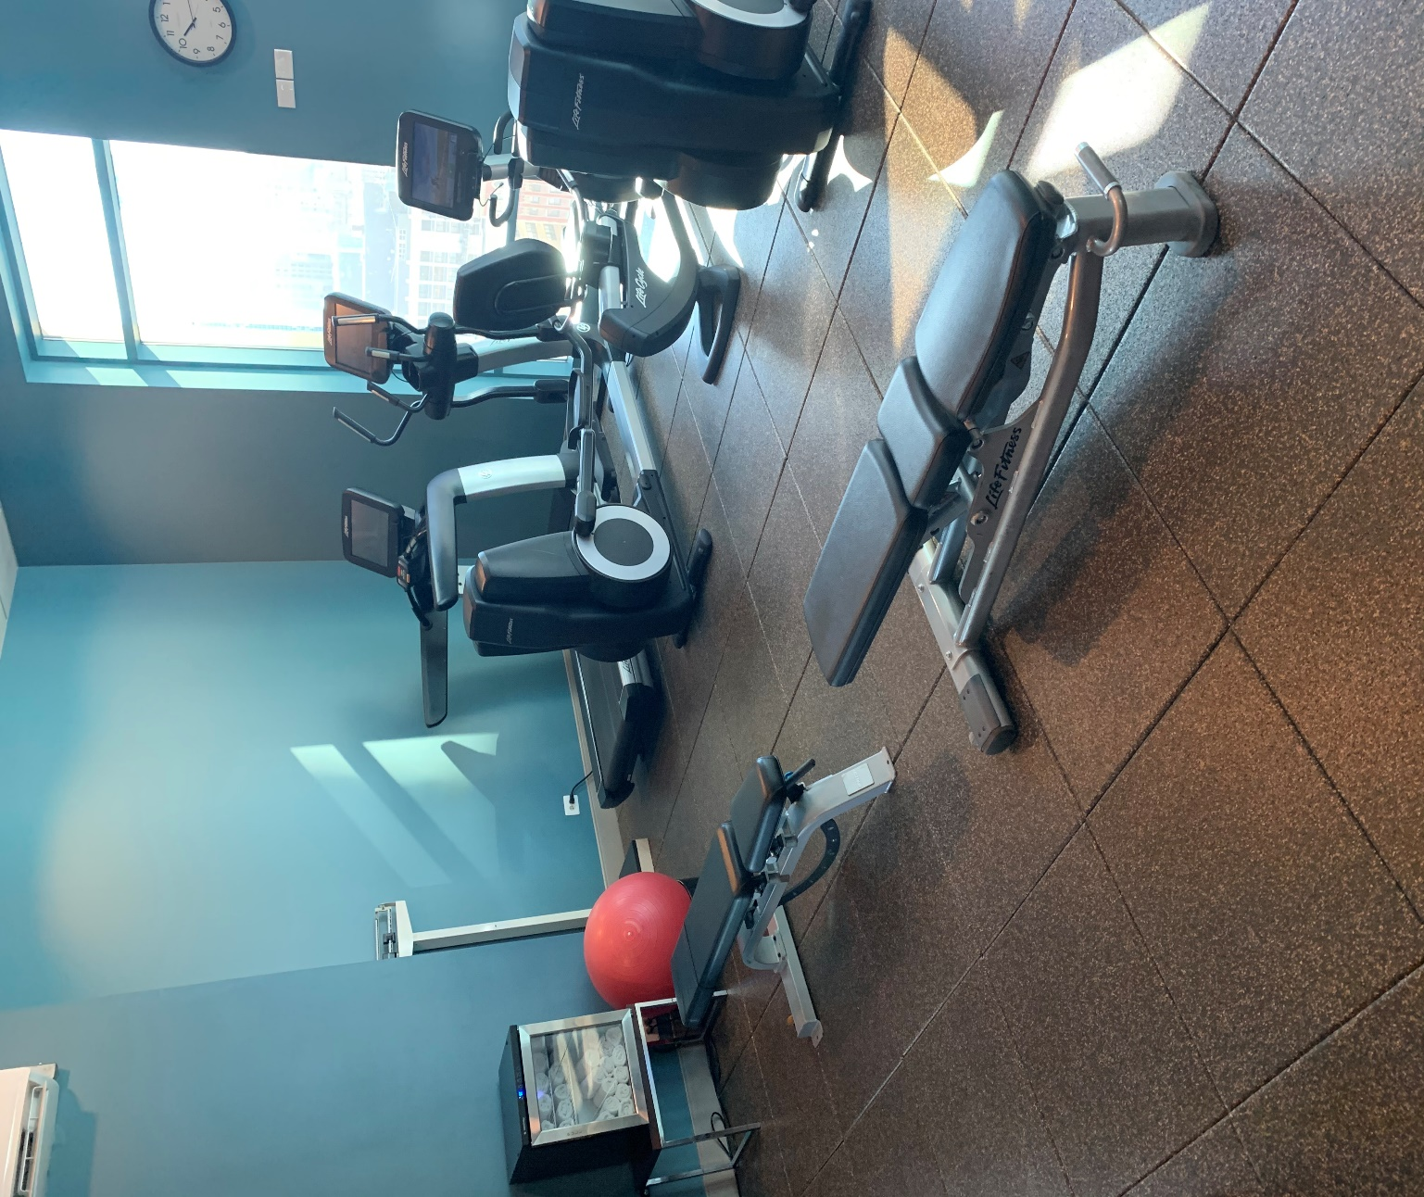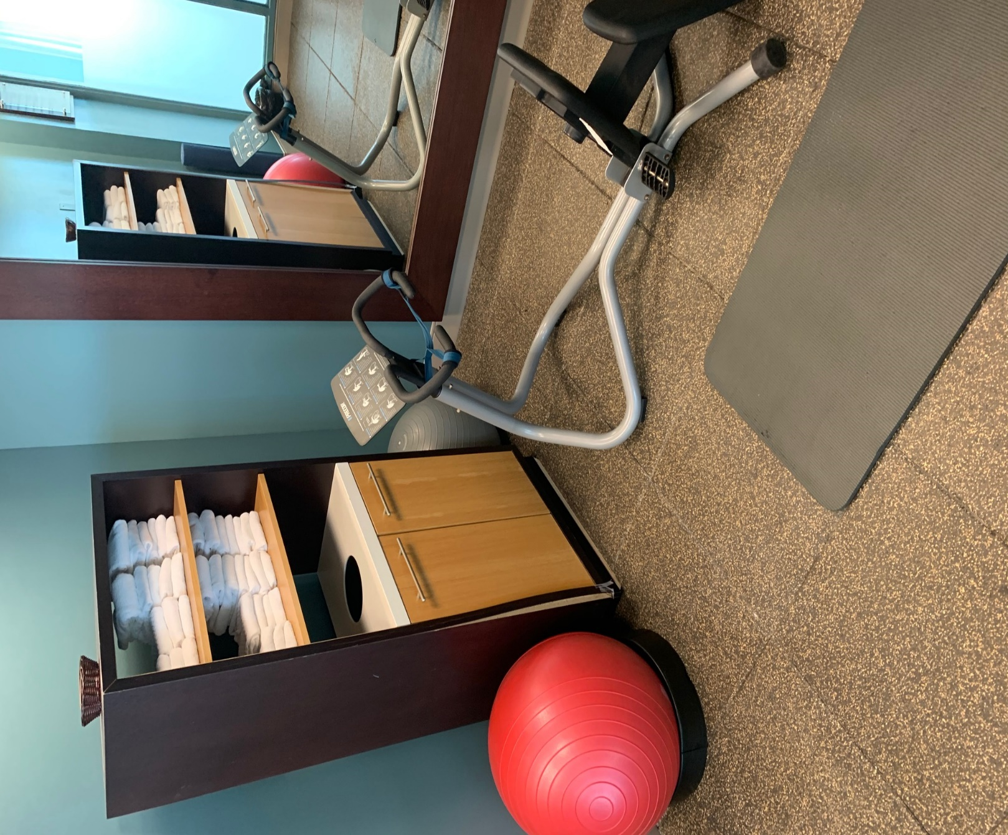

At your property we will perform the following methodology, a well-tested technique we have developed over the years in conjunction with the leading deep floorcare cleaning association and the largest floorcare manufacturers:

Our deep clean process for rubber gym floors-

Step #1: Pre-Spray all rubber tiles with an alkaline detergent to loosen soiling. All of our Hotel Hygiene® Plus chemicals are formulated specifically for Renue Systems.

Step #2: Scrub all rubber tiles with a rotary scrubber and soft bristle brushes.

Step #3: Clean and Rinse all tile with hot water and a special wand that recovers the dirty water from the cleaning process.

Step #4: Disinfect all tile with a green EPA approved disinfectant with a pleasant fragrance.

Step #5: Dry all tile with air movers. The area will be ready for occupancy 30 minutes after our cleaning.

Project details and costs for proposed cleaning

Service pack #1 Rubber Flooring:

- 3 Fitness center room floors (766 square feet total)…………………….…….$675
  - Add hand cleaning of all gym equipment……………………….…….$175

  - Add disinfecting of all gym equipment with the Clorox 360 System…$200

*Price does NOT include moving of any heavy gym equipment like treadmills, weight racks, etc. If you require this please let me know and we can adjust our manpower and pricing for your project.

PLEASE NOTE

Renue Systems will not be responsible for the following (but we can address):

- Compromised or missing grout
- Chipped or cracked tiles
- Flooring where grout lines have been painted and are not the original grout color
- Uneven surface coloring and cracks may be evident after floor is cleaned and free of sealer/wax and other coatings
- Some staining may be permanent in the stone and grout

*Some staining in the rubber tiles may be permanent and not removable with cleaning.

*Hotel to provide complimentary parking during project of cost will be billed back to the property.

*48 hour cancellation notice required or a 15% cancellation fee will be charged.

We will be glad to afford you payment terms to work within your budget

Please complete this service agreement, sign it and return it to your local Renue Systems service provider.

Scope of Service:

Description: ________________________________________________________________

______________________________________________________________________________

Payment Terms:

The sum of $________________ is the agreed upon price for the services rendered with payment to made as follows:

____________ payments each for $___________ according to the following schedule:
______________________________________________________________________________

Please check here if your property will be paying by P-Card ___ or check ___

Card # _________________________ Card type _________________ Exp. date __________

3 Digit Security Code (back of card)____________________

Acceptance of Service Agreement

The above pricing, specifications, terms and conditions are satisfactory and you are hereby authorized to commence the work as specified.

Name: _______________________________________________ Property:__________________________________

Signature: ____________________________________________ P.O. # (if needed):___________________________

Title: ________________________________________________ Date: _____________________________________

Phone: _______________________________________________ Email: ____________________________________

