Ryan McCallum June 30, 2015
Assistant General Manager
Hotel Blake Chicago
500 S. Dearborn
Chicago, IL 60605

Email: ryan.mccallum@bluegreenvacations.com

Thank you very much for the opportunity to once again earn your business. We are pleased to present you this proposal for the power washing of your entrance and sidewalks. If you have any questions regarding my proposal, please do not hesitate to call me.

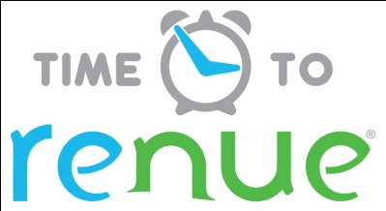

Why choose Renue Systems for your deep cleaning needs?

- We are the leading provider of comprehensive deep cleaning services exclusively to the hospitality industry – we have proudly serviced thousands of hotels over our 30 year history
- We are the only company that has been a North America approved vendor of Avendra since its formation
- Expertly trained, certified and uniformed employees that specialize in working in the hotel environment – no micromanaging of our team by your team is needed
- Proprietary equipment and chemicals, well-tested methodologies and significant ongoing R&D to provide top results
- Extremely responsive scheduling and highly flexible payment plans to meet your changing needs – we work when it is convenient to you and on a 24/7 basis
- Easy to understand and transparent pricing – and all our work is 100% guaranteed to your satisfaction

Renue’s Rapid Venue Restoration

Project details and costs for proposed cleaning

- Protect all glass and frames from chemical.
- Use caution cones to divide area being cleaned and caution motorist, pedestrians and guests of work being performed.
- Pre-treat all concrete with a high alkaline detergent for soiling deposits and an enzyme for the oil stains.
- Powers wash all areas with 4000psi, heated, trailer mounted power washer to remove soiling.
- Vacuum up any standing water using a commercial wet/dry vac.

We estimate this project taking one full day/evening to complete

- All entrance from doorway to the end of sidewalk at Dearborn & Congress just past Meli Restaurant

Cost for service…………………………………………….….…....$860.00

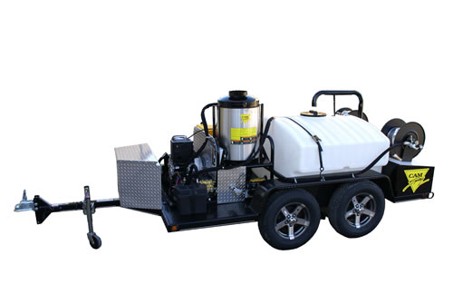

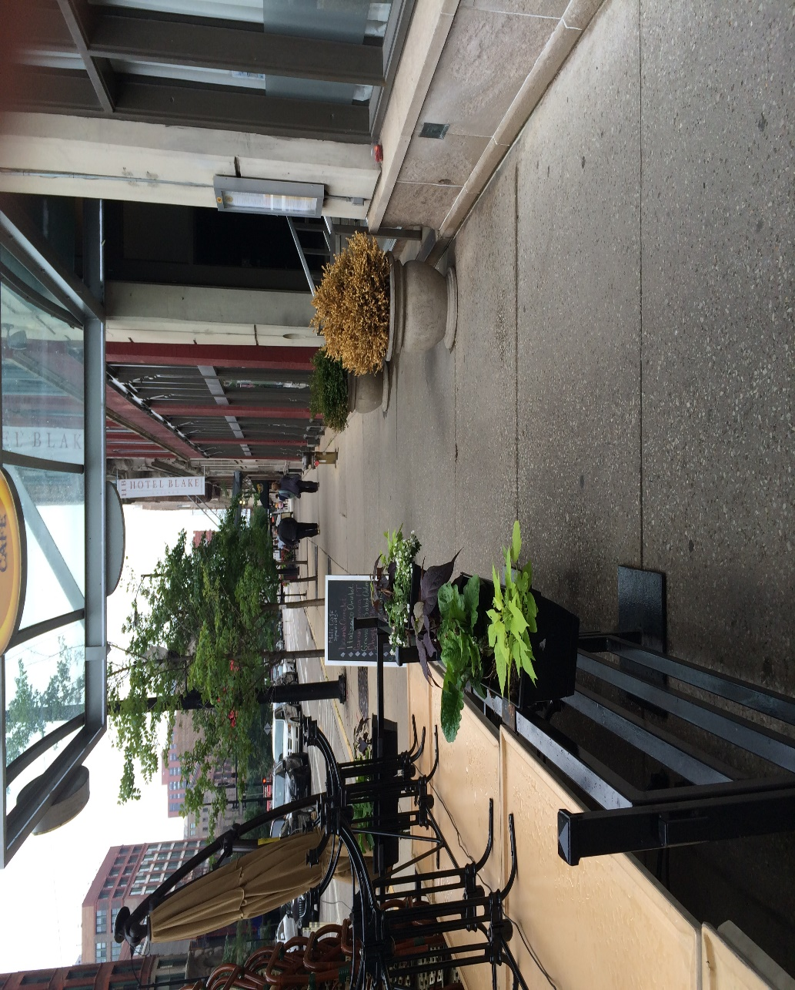

PLEASE NOTE:

*48 hour cancellation notice required or a 15% cancellation fee will be charged.

*Hotel will allow us to fill up our water supply at their facility for this cleaning. .

*Hotel will provide complimentary parking during any scheduled work or cost will be billed back to the hotel.

*Hotel will provide us a key and access to water spigot outside.

Note some staining in the concrete and stone walls may be permanent and not removable with cleaning

APPROVED VENDOR

Please complete this service agreement, sign it and return it to your local Renue Systems service provider.

Scope of Service:

Description: ________________________________________________________________
______________________________________________________________________________

Payment Terms:

The sum of $________________ is the agreed upon price for the services rendered with payment to made as follows:

____________ payments each for $___________ according to the following schedule:
______________________________________________________________________________

Please check here if your property will be paying by P-Card ___ or check ___

Card # _________________________ Card type _________________ Exp. date __________

3 Digit Security Code (back of card)____________________

Acceptance of Service Agreement

The above pricing, specifications, terms and conditions are satisfactory and you are hereby authorized to commence the work as specified.

Name: _______________________________________________ Property:__________________________________

Signature: ____________________________________________ P.O. # (if needed):___________________________

Title: ________________________________________________ Date: _____________________________________

Phone: _______________________________________________ Email: ____________________________________

