Lesley Hamre July 24, 2013
Assistant Director, Project Management
Studley
191 North Wacker Drive
Suite 2700
Chicago, IL 60606
E mail: LHamre@studley.com

Dear Ms. Hamre:

Thank you very much for the opportunity to earn your business. We are pleased to present you this proposal for the deep restoration cleaning of your upholstery. If you have any questions regarding my proposal, please do not hesitate to call me.

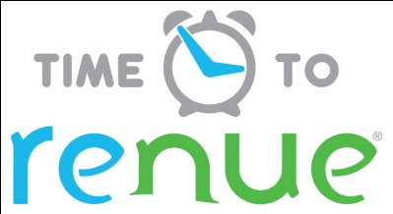

Why choose Renue Systems for your deep cleaning needs?

- We are the leading provider of comprehensive deep cleaning services exclusively to the hospitality industry – we have proudly serviced thousands of hotels over our 30 year history
- We are the only company that has been a North America approved vendor of Avendra since its formation
- Expertly trained, certified and uniformed employees that specialize in working in the hotel environment – no micromanaging of our team by your team is needed
- Proprietary equipment and chemicals, well-tested methodologies and significant ongoing R&D to provide top results
- Extremely responsive scheduling and highly flexible payment plans to meet your changing needs – we work when it is convenient to you and on a 24/7 basis
- Easy to understand and transparent pricing – and all our work is 100% guaranteed to your satisfaction

At your property we will perform the following methodology, a well-tested technique we have developed over the years in conjunction with the leading deep floorcare cleaning association and the largest floorcare manufacturers:

Our deep clean process-

- INSPECTION: All upholstery is inspected to determine fiber consistency.
- CHEMICAL: Chemical formulations are then constructed based on Fiber I.D.
- PRESPRAY: Upholstery is then pre-treated using Renue System’s exclusive soil release chemical.
- AGITATION: Heavily soiled areas are addressed using soft brushes that reach deep into the material and loosen the imbedded soil.
- CLEANING: Upholstery is cleaned with hot water extraction (HWE) to remove the overall soil load. HWE has been proven the best method to remove the largest amount of soil from upholstery and is the preferred method of cleaning by most manufacturers.
- NEUTRALIZATION: An all-fiber rinse agent is used during the extraction process to soften and brighten colors of the upholstery fibers.
- DEODORIZER: A deodorizing solution is included in every service. We have a multitude of fragrances for the hotel to choose from.
- DRY TIME: Most upholstery dries within 2 hours of cleaning.

Project details and costs for proposed cleaning

Office Upholstery:

- 60 fabric side chairs……….………………………..…$480.00*

PLEASE NOTE:

*48 hour cancellation notice required or a 15% cancellation fee will be charged.

*Property to provide parking for Renue staff or cost for parking will be billed back to the client.

*Property will provide access to all material in a contiguous fashion and immediately upon arrival to Renue System technicians during scheduled cleaning.

Note some staining in the upholstery fibers may be permanent and not removable with cleaning

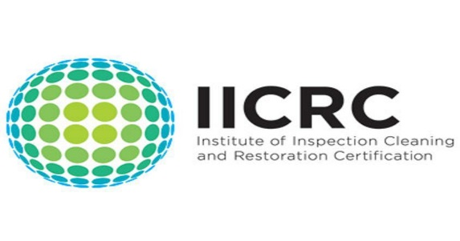

Please complete this service agreement, sign it and return it to Renue Systems.

Scope of Service:

Description: ________________________________________________________________

______________________________________________________________________________

Payment Terms:

The sum of $____________is the agreed upon price for the services rendered with payment to made as follows:

1 payments each for $__________according to the following schedule:

______________________________________________________________________________

Please check here if your property will be paying by P-Card ___ or credit card ___

Card # _________________________ Card type _________________ Exp. date __________

3 Digit Security Code (back of card)____________________

Acceptance of Service Agreement

The above pricing, specifications, terms and conditions are satisfactory and you are hereby authorized to commence the work as specified.

Name: _______________________________________________ Property:__________________________________

Signature: ____________________________________________ P.O. # (if needed):___________________________

Title: ________________________________________________ Date: _____________________________________

Phone: _______________________________________________ Email: ____________________________________

