Mr. Phil Tsilis March 18, 2020
Director of Housekeeping
Peninsula Hotel
108 East Superior Street
Chicago, IL 60611

Email: philTSILIS@peninsula.com

Dear Mr. Tsilis:

Thank you very much for the opportunity to earn your business. We are pleased to present to you this proposal for the disinfecting and sanitizing areas of your facility using the Clorox® Total 360® System. If you have any questions regarding my proposal, please do not hesitate to call me.

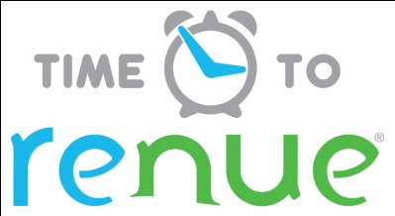

Why choose Renue Systems for your deep cleaning needs?

- We are the leading provider of comprehensive deep cleaning services exclusively to the hospitality industry – we have proudly serviced thousands of hotels over our 30 year history
- We are the only company that has been a North America approved vendor of Avendra since its formation
- Expertly trained, certified and uniformed employees that specialize in working in the hotel environment – no micromanaging of our team by your team is needed
- Proprietary equipment and chemicals, well-tested methodologies and significant ongoing R&D to provide top results
- Extremely responsive scheduling and highly flexible payment plans to meet your changing needs – we work when it is convenient to you and on a 24/7 basis
- Easy to understand and transparent pricing – and all our work is 100% guaranteed to your satisfaction

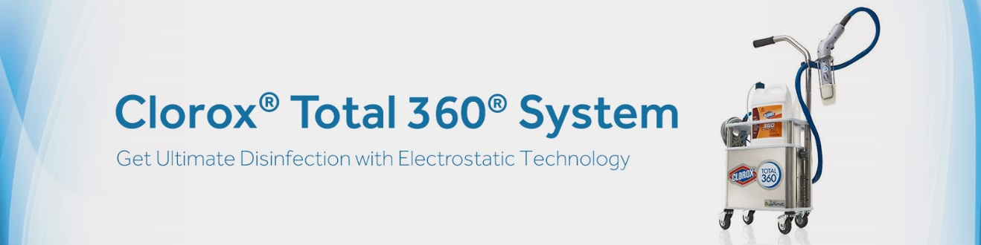

Renue Systems- Powered by Clorox® - is proud to introduce our newest service offering:
The Clorox® Total 360® System.

Clorox® Total 360® is a hard surface disinfecting system that uses electrostatic spray to kill viruses, bacteria and germs, and gives you a healthier facility. Used throughout facilities in all public and common spaces, locker rooms, bathrooms, dining areas, classroom areas, and back of house and food preparation areas to create a cleaner and healthier environment.

Benefits to your property include the following:

- Reduces employee illnesses and missed time to illnesses
- Gives your guests and staff piece-of-mind in your superior cleaning protocols and effort to reduce germs and prevent illnesses
- Eliminates bacteria that causes odors
- Over 50 organism kill claims- Kills cold and flu viruses, Human coronavirus, MRSA and Norovirus in 2 minutes or less
- One step disinfecting. The process is fast! Most areas are completed in just a few minutes and can be reopened for occupancy in 5 minutes or less.
- Used in hospitals, schools and healthcare facilities across the country and now available in hospitality.

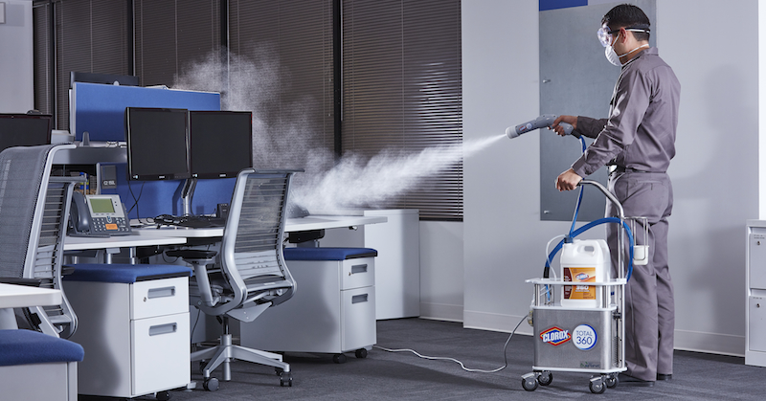

At your property we will perform the above methodology, a well-tested system developed by Clorox to help prevent the spread of illness-causing germs. The Clorox® Total 360® System lets us do it in less time and with less product so we can provide a cost effective, efficient, comprehensive surface treatment that delivers an even cleaner, healthier environment for your guests and employees.

Project details and costs for proposed cleaning

- Service most likely would be Sunday evenings.
- Areas to include hard surfaces that are common touchpoints
- Any food preparation contact points should be cleaned by hotel staff after our disinfecting process is complete
- Glassware, silverware and similar items should be moved prior to our disinfecting or washed immediately after.

Areas and pricing:

Entire facility top to bottom with the exception of inside the individual guestrooms.

All common touch points will be treated in the areas below such as:
light switches, sinks, toilets, faucets, door handles, hand rails, restroom walls, countertops, stall partition walls/doors, towel/soap, dispensers, tables, chairs, keyboards, phone handles, and other unique touch surfaces of your facility.

Cost………………………………………………………………….$45,000.00

PLEASE NOTE:

*All pricing quoted is for the preventative measures only NOT confirmed outbreak.

*72 hour cancellation notice required or a 15% cancellation fee will be charged.

*Property will provide access to areas at designated dates and times.

*We reserve the right to substitute the chemical used based on supply.

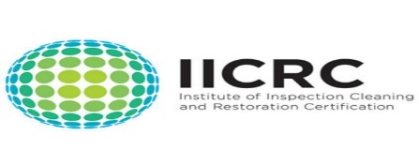
APPROVED VENDOR

Please complete this service agreement, sign it and return it to your local Renue Systems service provider.

Scope of Service:

Description: ________________________________________________________________

______________________________________________________________________________

Payment Terms:

The sum of $45,000.00 is the agreed upon price for the services rendered with payment to made as follows:

One payment each for $45,000.00 according to the following schedule: 30 days net terms

______________________________________________________________________________

Please check here if your property will be paying by P-Card ___ or check ___

Card # _________________________ Card type _________________ Exp. date __________

3 Digit Security Code (back of card)____________________

We reserve the right to charge a credit card fee for a project paid by credit card exceeding $10,000

Acceptance of Service Agreement

The above pricing, specifications, terms and conditions are satisfactory and you are hereby authorized to commence the work as specified.

Name: _______________________________________________ Property:__________________________________

Signature: ____________________________________________ P.O. # (if needed):___________________________

Title: ________________________________________________ Date: _____________________________________

Phone: _______________________________________________ Email: ____________________________________

