**Shay Strzemp-Green January 27, 2016**

Executive Housekeeper

**Hyatt Regency McCormick Place**

2233 S. Martin Luther King Drive

Chicago, IL 60616

Email: [shay.strzemp-green@hyatt.com](mailto:shay.strzemp-green@hyatt.com)

Dear Shay-

Thank you very much for the opportunity to earn your business. We are pleased to present you this proposal for the **Ren** cleaning pads and tools for the interim cleaning of your escalators in-house. If you have any questions regarding my proposal, please do not hesitate to call me.

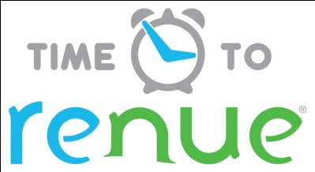

***Why choose* Renue Systems *for your deep cleaning needs?***

* We are the leading provider of comprehensive deep cleaning services exclusively to the hospitality industry – we have proudly serviced thousands of hotels over our 30 year history
* We are the only company that has been a North America approved vendor of **Avendra** since its formation
* Expertly trained, certified and uniformed employees that specialize in working in the hotel environment – no micromanaging of our team by your team is needed
* Proprietary equipment and chemicals, well-tested methodologies and significant ongoing R&D to provide top results
* Extremely responsive scheduling and highly flexible payment plans to meet your changing needs – we work when it is convenient to you and on a 24/7 basis
* Easy to understand and transparent pricing – and all our work is 100% guaranteed to your satisfaction



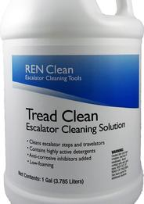

**Features & Benefits of Ren Escalator Cleaning Pads:**

**REN escalator cleaning tools**

Clean your escalator in as little as 5 minutes!

The **REN**™ system cleans any brand, size or style of escalator or travelator in minutes, not hours.

* One person operational.
* Stopping the escalator is not required.
* No external power source needed.
* Lightweight design makes it easy to transport and simple to store.
* Engineered sponge pads clean the toughest stains, effectively and gently.
* Pads can be cleaned and reused.
* Emergency response to spills in just minutes.

Schedule your escalators to be cleaned at the same frequency as all other flooring areas.  Daily or weekly scheduled cleaning provides a cleaner, safer environment for your property, consistently and cost effectively.

Get your dirty or neglected escalators back up to your properties maintenance and cleanliness standards.  Lower customer complaints and avoid embarrassing stain and dirt buildup on your escalators.

Lower your exposure to slip and fall litigation by instituting a cleaning procedure to rapidly and effectively clean potential hazards from spilled drinks. Keep your escalators looking clean and operating safely.

Tread Clean escalator liquid concentrate for maintaining and restoring escalator cleanliness. REN™ Clean System provides maximum results when TREAD CLEAN is used as instructed with Cleaning Pads. Special non-corrosive formulation will not harm escalator mechanics, plastic parts, aluminum or painted treads.  TREAD CLEAN dries quickly leaving no sticky residue.

All TREAD CLEAN components are low toxicity, biodegradable, meeting or exceeding VOC requirements.  It also contains no Clean Air Act Hazardous Air Pollutants (HAPS), nor is it a RCRA hazardous waste.

**Pricing for a full kit for your 24” escalators:**

(1) 24” Trough kit (black pan and pad holder)…………………………………$280.00

(1) Case of 24” V Spec Cleaning Pads (12 pads in case)………………………$330.00

(1) Telescoping Handle…………………………………………………………$38.00

(1) Case of Tread Clean Concentrate…………………………………………..$180.00

Total……………………………………………………………………………………..$828.00*

**PLEASE NOTE:**

*\*Pricing quoted above* ***does not include tax and shipping****. Please call 630.691.0800 to get your shipping and tax price when placing your order or email* [contact@renuesystems.com](mailto:contact@renuesystems.com)

*\*Please allow 4-7 days delivery time.*

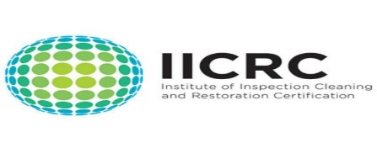



**APPROVED VENDOR**

*Please complete this service agreement, sign it and return it to your local Renue Systems service provider.*

**Scope of Service:**

Description: ________________________________________________________________

______________________________________________________________________________

**Payment Terms:**

The sum of $________________ is the agreed upon price for the services rendered with payment to made as follows:

____________ payments each for $___________ according to the following schedule:

______________________________________________________________________________

Please check here if your property will be paying by P-Card ___ or check ___

*Card #* _________________________ *Card type* _________________ *Exp. date* __________

*3 Digit Security Code (back of card)____________________*

*We reserve the right to charge a credit card fee for a project paid by credit card exceeding $10,000*

**Acceptance of Service Agreement**

The above pricing, specifications, terms and conditions are satisfactory and you are hereby authorized to commence the work as specified.

Name: _______________________________________________ Property:__________________________________

Signature: ____________________________________________ P.O. # (if needed):___________________________

Title: ________________________________________________ Date: _____________________________________

Phone: _______________________________________________ Email: ____________________________________