David Neira November 11, 2017
Director of Engineering

Marriott Oakbrook
1401 W. 22nd Street
Oakbrook, IL 60523

E mail: david.neira@marriott.com

David-

Thank you very much for interest in the services we provide to the hospitality industry. We are pleased to present you this proposal for the deep cleaning of your in-room coil units. If you have any questions regarding my proposal, please do not hesitate to call me.

Why choose Renue Systems for your deep cleaning needs?

- We are the leading provider of comprehensive deep cleaning services exclusively to the hospitality industry – we have proudly serviced thousands of hotels over our 30 year history
- We are the only company that has been a North America approved vendor of Avendra since its formation
- Expertly trained, certified and uniformed employees that specialize in working in the hotel environment – no micromanaging of our team by your team is needed
- Proprietary equipment and chemicals, well-tested methodologies and significant ongoing R&D to provide top results
- Extremely responsive scheduling and highly flexible payment plans to meet your changing needs – we work when it is convenient to you and on a 24/7 basis
- Easy to understand and transparent pricing – and all our work is 100% guaranteed to your satisfaction

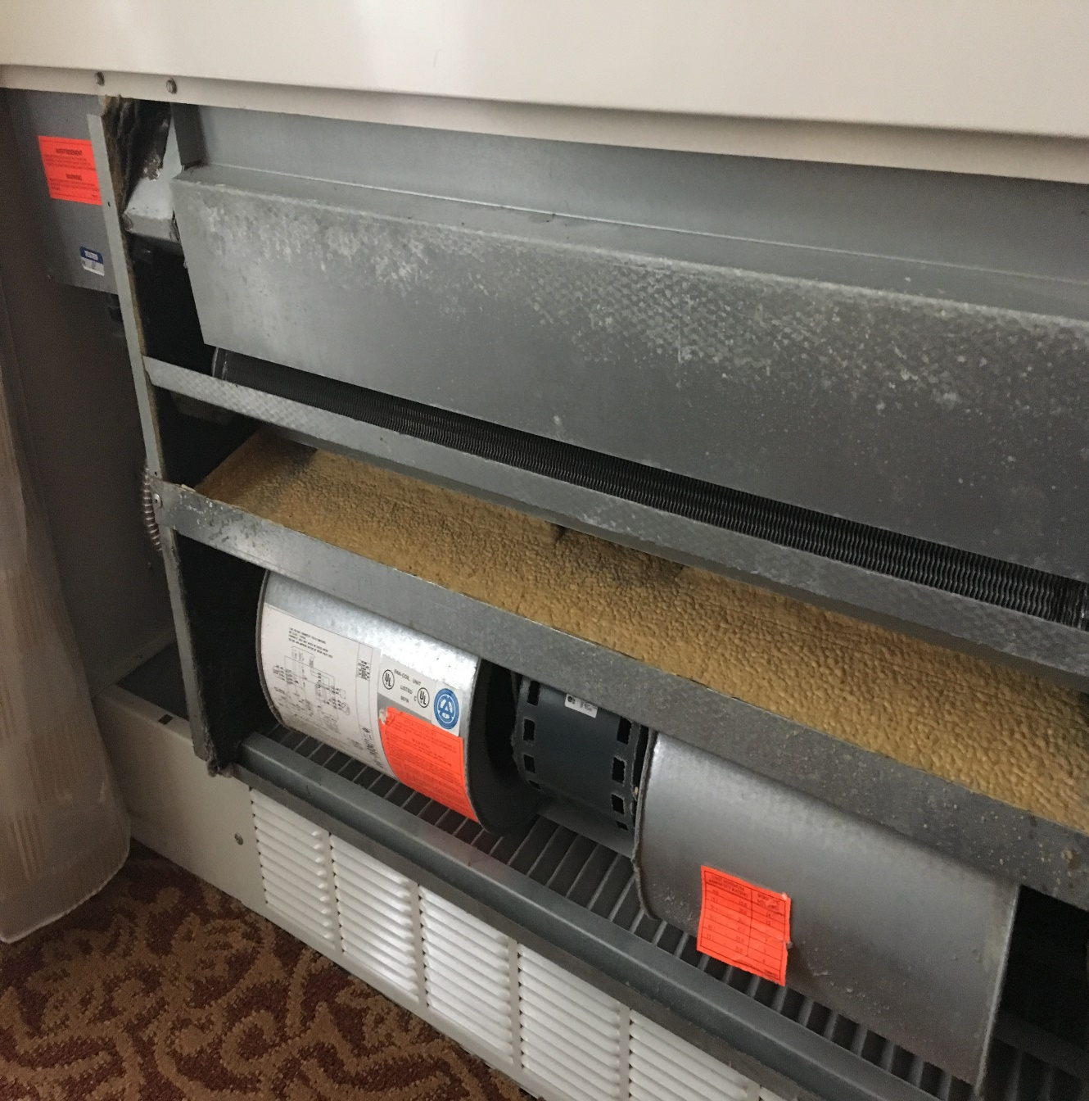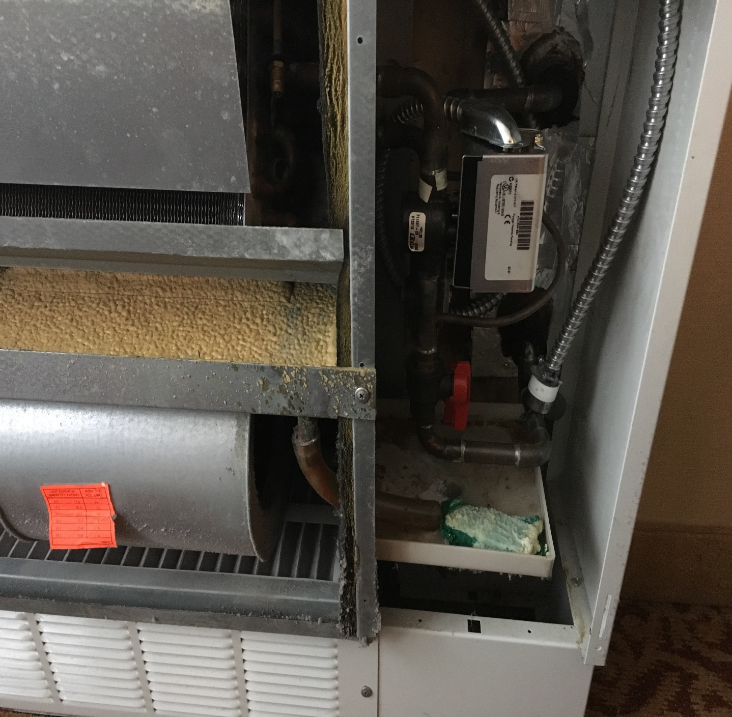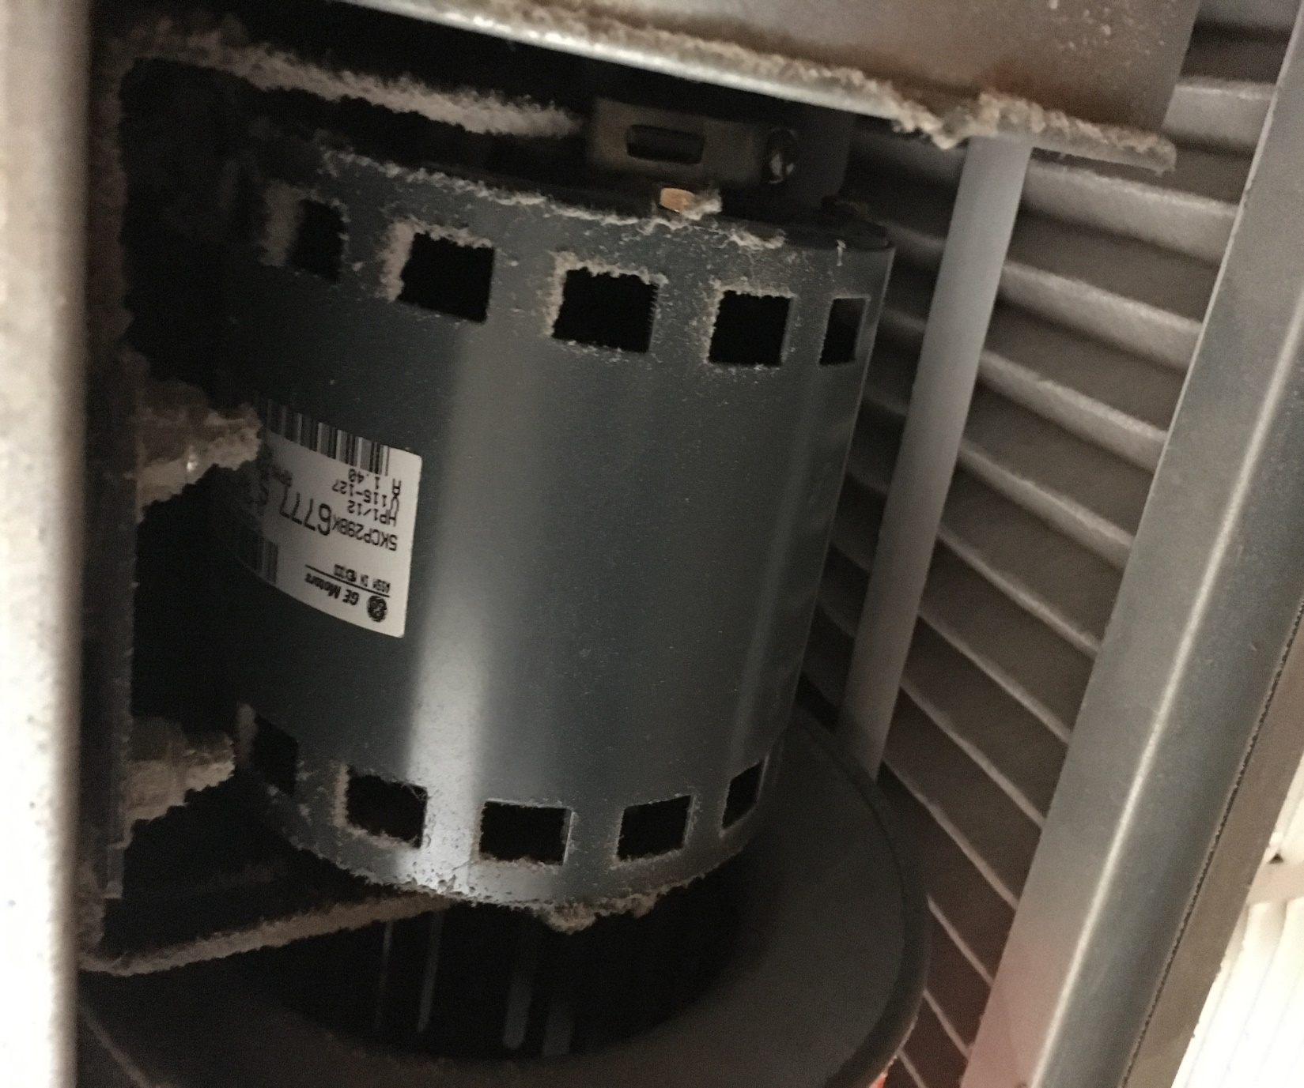

Project details and cost for cleaning of 2 pipe coil systems units

Step #1: Shut off power to unit
Step #2: Remove cover to unit.
Step #3: Remove dirty air filter and vacuum or replace. Hotel to provide new filters if they are to be replaced.
Step #4: Install catch pan under unit to capture any water during cleaning.
Step #5: Remove discharge covers and spray room side of A-coil with Simple Green cleaning solution.
Step #6: Pressure spray coils and blower wheels with low psi (about 30-50 psi) water and extract. Clean small catch pan with unit as well. We will cover small motor between two squirrel cage blowers to ensure no water enters the motor.
Step #7: Inspect upper drain pan and hose (if plugged or restricted, remove and flush to ensure proper drainage)
Step #8: Install bacteria strip if desired.
Step #9: Replace any hardware removed from unit in order to clean.
Step #10: Test unit to ensure it is working

372 Wall mounted Cleaning only…………………………….…….………………. $13,020.00

25 Ceiling or overhead cleaning only………………………………………………..$1,875.00

Biocide strips / tablets……………………………………………………………Add $2 per unit

*48 hour cancellation notice required or a 15% cancellation fee will be charged.

*Hotel will provide complimentary parking during any scheduled service.

*Hotel will provide access to guestrooms in the best contiguous fashion as possible.

*All invoicing will be 30 days net terms.

We will be glad to afford you payment terms to work within your budget
APPROVED VENDOR

Please complete this service agreement, sign it and return it to your local Renue Systems service provider.

Scope of Service:

Description: ________________________________________________________________
______________________________________________________________________________

Payment Terms:

The sum of $________________ is the agreed upon price for the services rendered with payment to made as follows:

____________ payments each for $___________ according to the following schedule:
______________________________________________________________________________

Please check here if your property will be paying by P-Card ___ or check ___

Card # _________________________ Card type _________________ Exp. date __________

3 Digit Security Code (back of card)____________________

We reserve the right to charge a credit card fee for a project paid by credit card exceeding $10,000

Acceptance of Service Agreement

The above pricing, specifications, terms and conditions are satisfactory and you are hereby authorized to commence the work as specified.

Name: _______________________________________________ Property:__________________________________

Signature: ____________________________________________ P.O. # (if needed):___________________________

Title: ________________________________________________ Date: _____________________________________

Phone: _______________________________________________ Email: ____________________________________

