Tim Regan October 26, 2018
Director of Housekeeping
Hotel Monaco
225 N. Wabash
Chicago, IL 60601

Email: tim.regan@hotelmonaco.com

Dear Mr. Regan:

We are pleased to present you this proposal for the deep restoration of your marble floors. After examining your property and discussing your needs, I have prepared the service outline below. If you have any questions regarding my proposal, please do not hesitate to call me. We estimate the initial restoration project taking 2-3 evenings of eight hour shifts to complete.

Why choose Renue Systems for your deep cleaning needs?

- We are the leading provider of comprehensive deep cleaning services exclusively to the hospitality industry – we have proudly serviced thousands of hotels over our 30 year history
- We are the only company that has been a North America approved vendor of Avendra since its formation
- Expertly trained, certified and uniformed employees that specialize in working in the hotel environment – no micromanaging of our team by your team is needed
- Proprietary equipment and chemicals, well-tested methodologies and significant ongoing R&D to provide top results
- Extremely responsive scheduling and highly flexible payment plans to meet your changing needs – we work when it is convenient to you and on a 24/7 basis
- Easy to understand and transparent pricing – and all our work is 100% guaranteed to your satisfaction

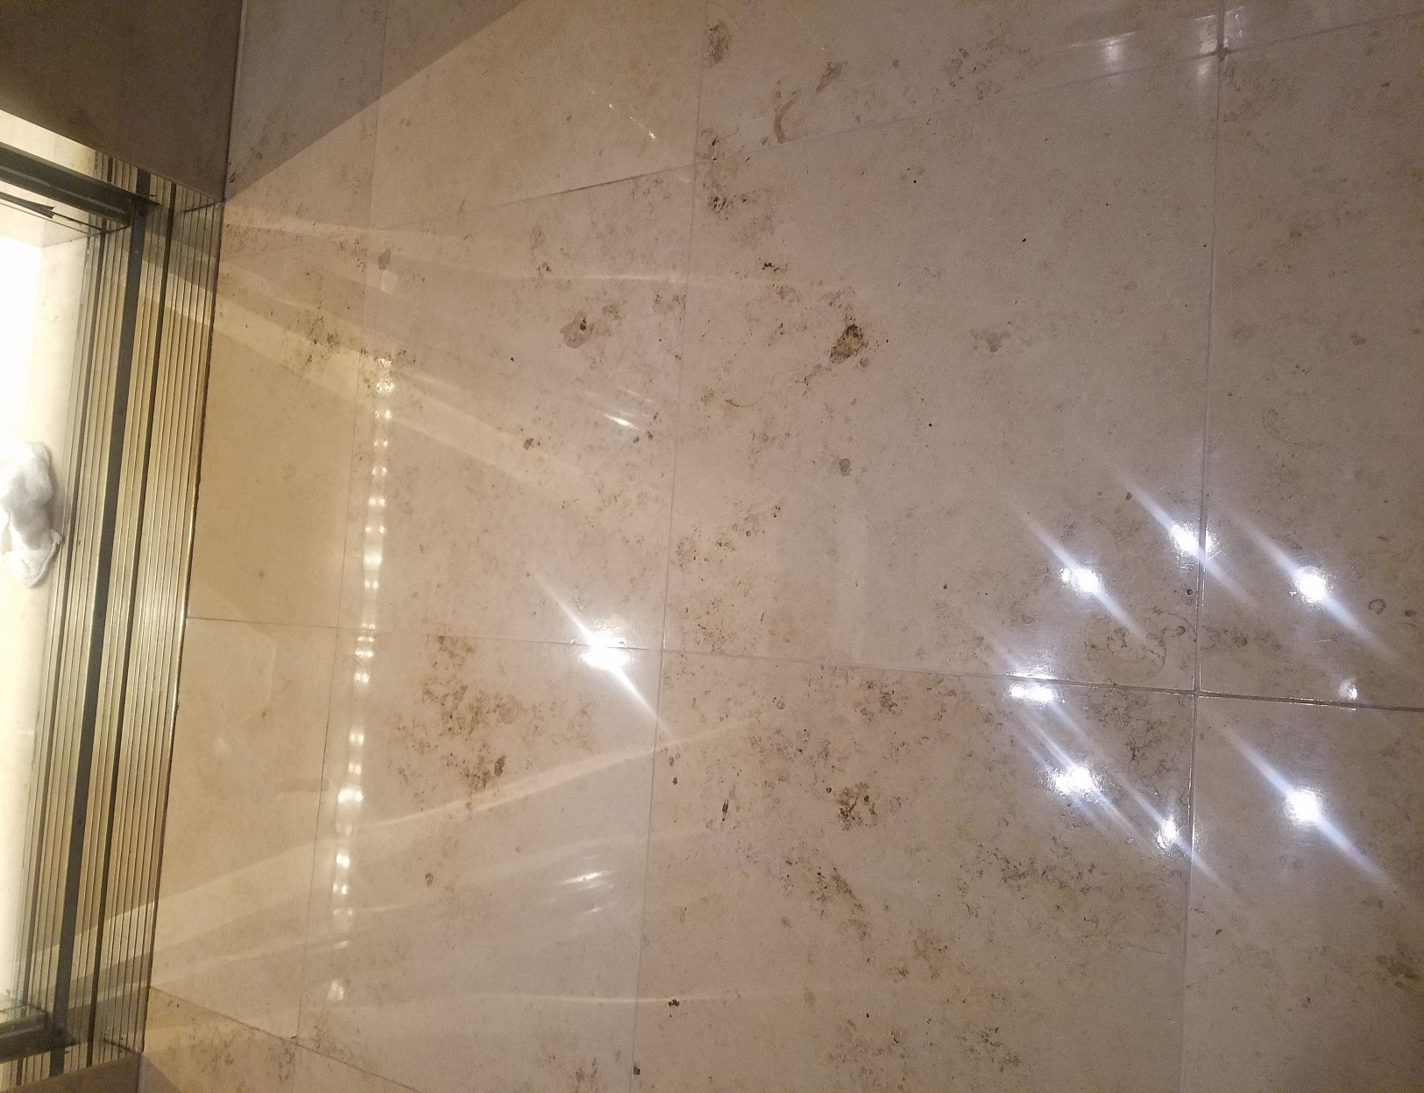

Current condition of flooring:

Your marble flooring consists of two types of tile called Imperial Gold & Dark Emperador. These types of marble are beautiful stones but are extremely soft and susceptible to scratching. The floor appears to have some medium to deep scratches with no excessive lippage or unevenness to the flooring. The polish has worn off in some traffic areas making it seem dull in appearance.

Recommendation:

It is our professional opinion that your floor be deep cleaned, diamond honed (grinding) along with polishing to return it back to state where the surface is free from most scratches and has a nice deep, reflective luster.

Our deep clean process:

At your property we will perform the following methodology, a well-tested technique we have developed over the years in conjunction with the leading marblecare restoration association:

Step #1: PREP all adjacent areas such as glass, wood, metal, carpeting, etc., with a protective film covering before any of the stone floor restoration begins. Place caution cones and wet floor signs around work area to warn customers and employees of any potential slip and fall hazards in the immediate work area.

Step #2: CLEAN marble with fluoride salts to remove soiling and enhance appearance of the grout lines. All of our Hotel Hygiene®Plus chemicals are formulated specifically for Renue Systems.

Step #3: DIAMOND HONE all marble tile, once each, with 100/200, 400, 600, 800, 1500 & 3000 grit diamonds (grit is a measure of abrasiveness). This multi-step restoration process strips the top surface off the stone removing the deeply embedded scratches and creates a new surface ready to accept polishing. The higher the stone is refined with these diamonds, the more reflective the surface the stone becomes.

Step #4: POLISH all marble using our very own polishing powder. This process enhances the natural color of the stone and provides a deep and high-gloss finish.

Step #5: SEAL (optional) all flooring with Renue’s Stone Impregnator. This sealer will protect the stone from staining and possible prevent irreversible damage to the stone.

Pricing for lobby Restoration:

All lobby floors
2 Marble Elevators

Total……………………...……………………………………………………$2,500.00

Ongoing Maintenance Service Plan:

Ongoing maintenance will only be provided if Renue Systems does the initial restoration of the flooring. This process of an ongoing maintenance plan, while not mandatory, will ensure that the investment made in restoring your marble floors will continue to have a high gloss and shine throughout the years to come.

Semiannual (2x per year) deep cleaning of the stone, light diamond honing of the surface scratches and re-polishing of the dull areas in main lobby & 2 marble elevators.

Total………..…………………………………………………………..$1,050.00 per visit

We will be glad to afford you payment terms to work within your budget.

PLEASE NOTE

Renue Systems will not be responsible for the following (but can address):

- Chipped or cracked tiles
- Filling of mineral deposit holes in stone unless previously specified
- Compromised or missing grout
- Flooring where grout lines have been painted and are not the original grout color
- Uneven surface coloring and cracks that may be evident after floor is cleaned and free of sealer/wax and other coatings
- Permanent stains in the stone and grout
- Deep scratches may not be completely removed. Impact marks that appear to be scratches are bruises in the stone that cannot be removed with restoration
- Price does not include grout repairs, cleaning of grout lines or replacement of any areas that are caulked.

*48 hour cancellation notice required or a 15% cancellation fee will be charged.

*Hotel will provide complimentary parking during any scheduled work or cost will be billed back to the hotel.

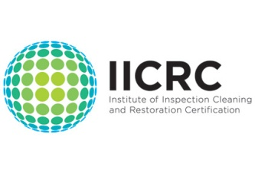
APPROVED VENDOR

Please complete this service agreement, sign it and return it to your local Renue Systems service provider.

Scope of Service:

Description: ________________________________________________________________

______________________________________________________________________________

Payment Terms:

The sum of $________________ is the agreed upon price for the services rendered with payment to made as follows:

____________ payments each for $___________ according to the following schedule:
______________________________________________________________________________

Please check here if your property will be paying by P-Card ___ or credit card ___

Card # _________________________ Card type _________________ Exp. date __________

3 Digit Security Code (back of card):______________

Acceptance of Service Agreement

We reserve the right to charge a credit card fee for a project paid by credit card exceeding $10,000

The above pricing, specifications, terms and conditions are satisfactory and you are hereby authorized to commence the work as specified.

Name: _______________________________________________ Property:__________________________________

Signature: ____________________________________________ P.O. # (if needed):___________________________

Title: ________________________________________________ Date: _____________________________________

Phone: _______________________________________________ Email: ____________________________________

