Chanielle Beach February 27, 2018
Director of Housekeeping

Viceroy Hotel
1118 N. State Street
Chicago, IL 60611

Email: chanielle.beach@viceroyhotelsandresorts.com

Dear Chanielle:

Thank you very much for the opportunity to once again earn your business. We are pleased to present you this proposal for the power washing at your facility. If you have any questions regarding my proposal, please do not hesitate to call me.

Why choose Renue Systems for your deep cleaning needs?

- We are the leading provider of comprehensive deep cleaning services exclusively to the hospitality industry – we have proudly serviced thousands of hotels over our 30 year history
- We are the only company that has been a North America approved vendor of Avendra since its formation
- Expertly trained, certified and uniformed employees that specialize in working in the hotel environment – no micromanaging of our team by your team is needed
- Proprietary equipment and chemicals, well-tested methodologies and significant ongoing R&D to provide top results
- Extremely responsive scheduling and highly flexible payment plans to meet your changing needs – we work when it is convenient to you and on a 24/7 basis
- Easy to understand and transparent pricing – and all our work is 100% guaranteed to your satisfaction

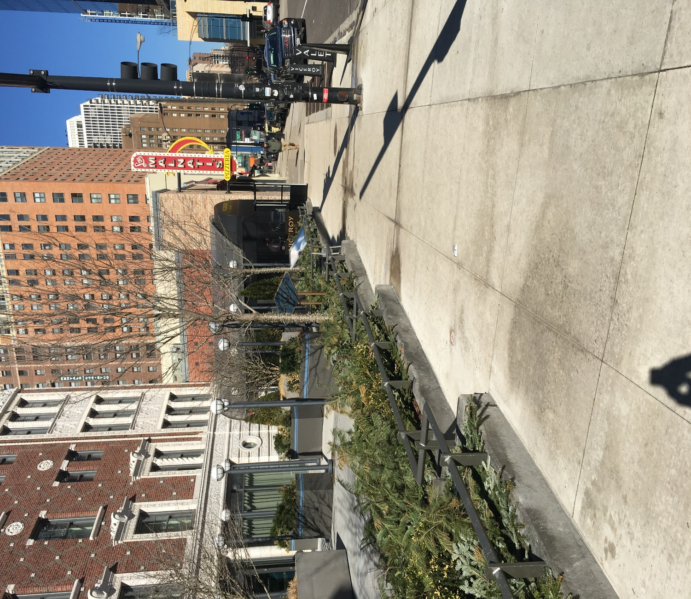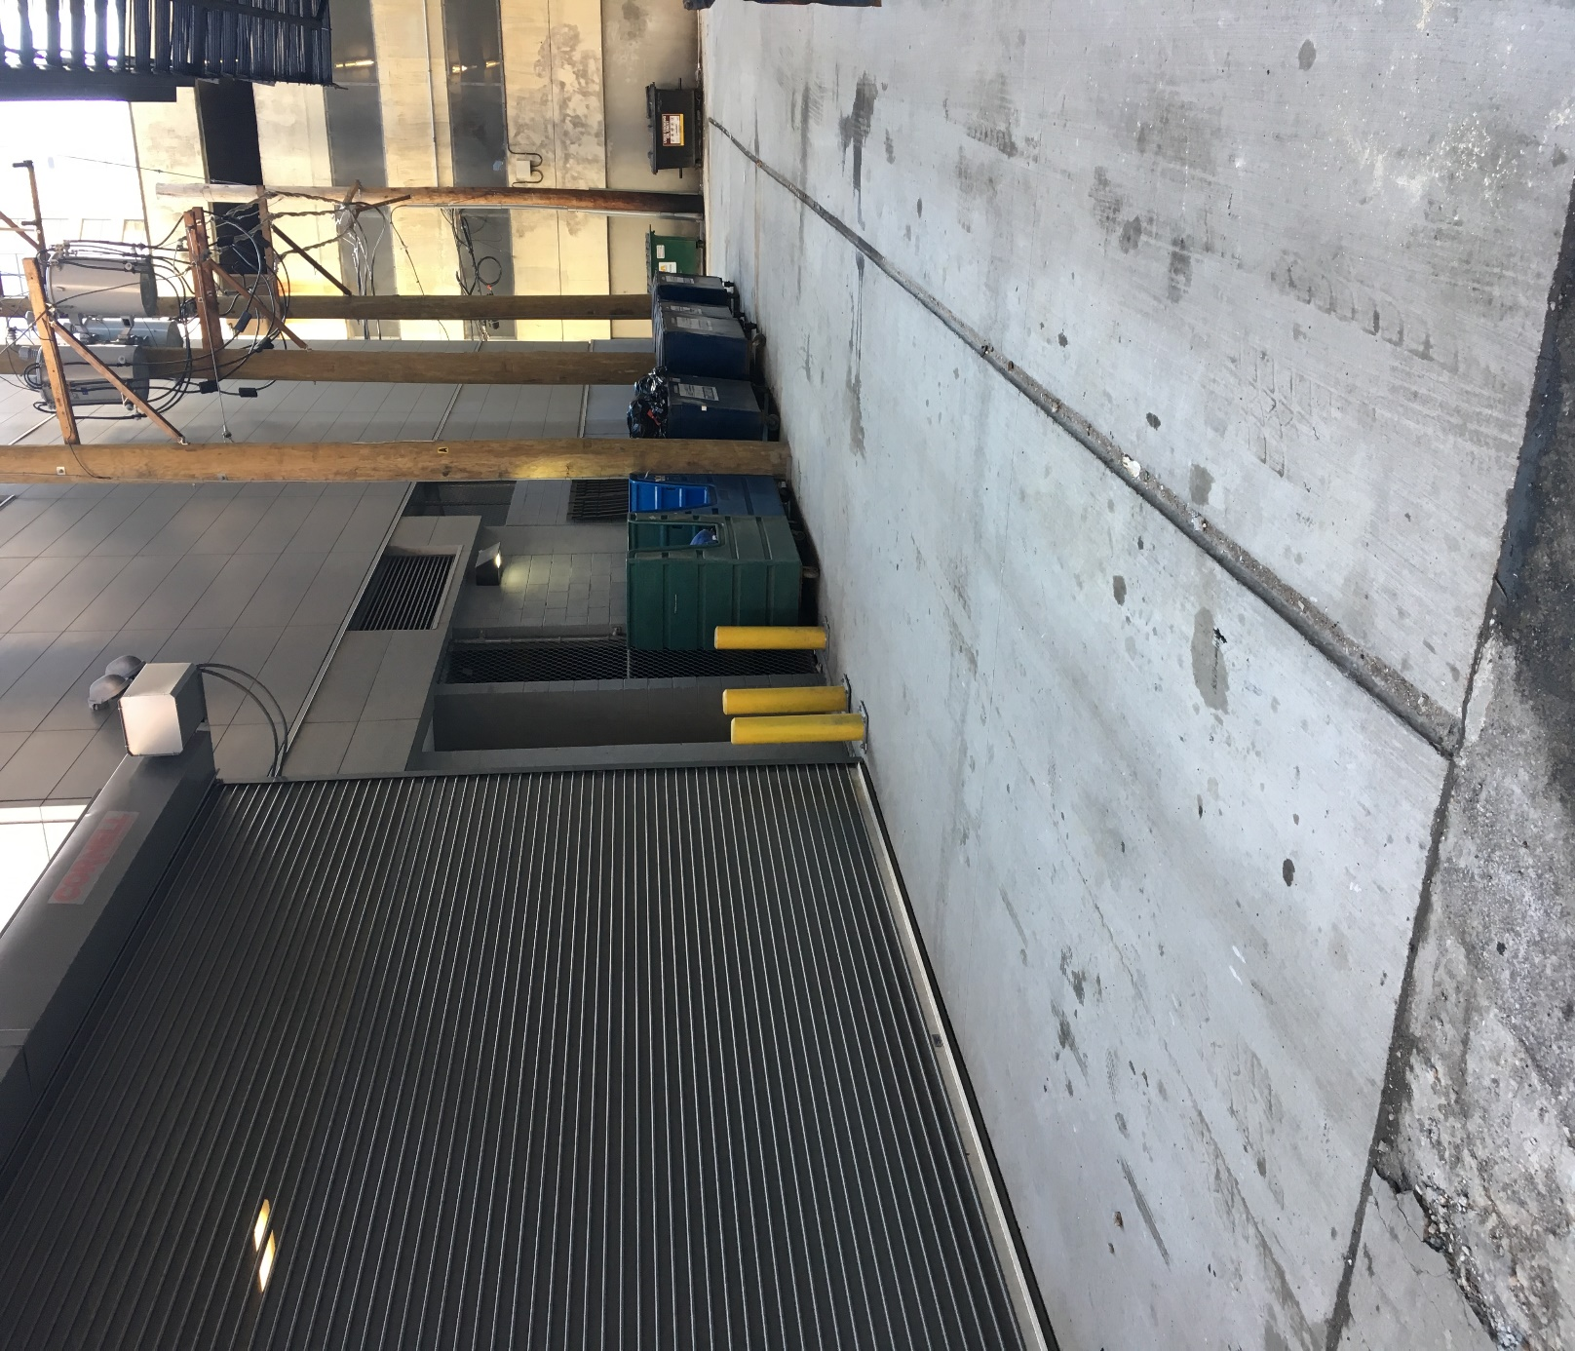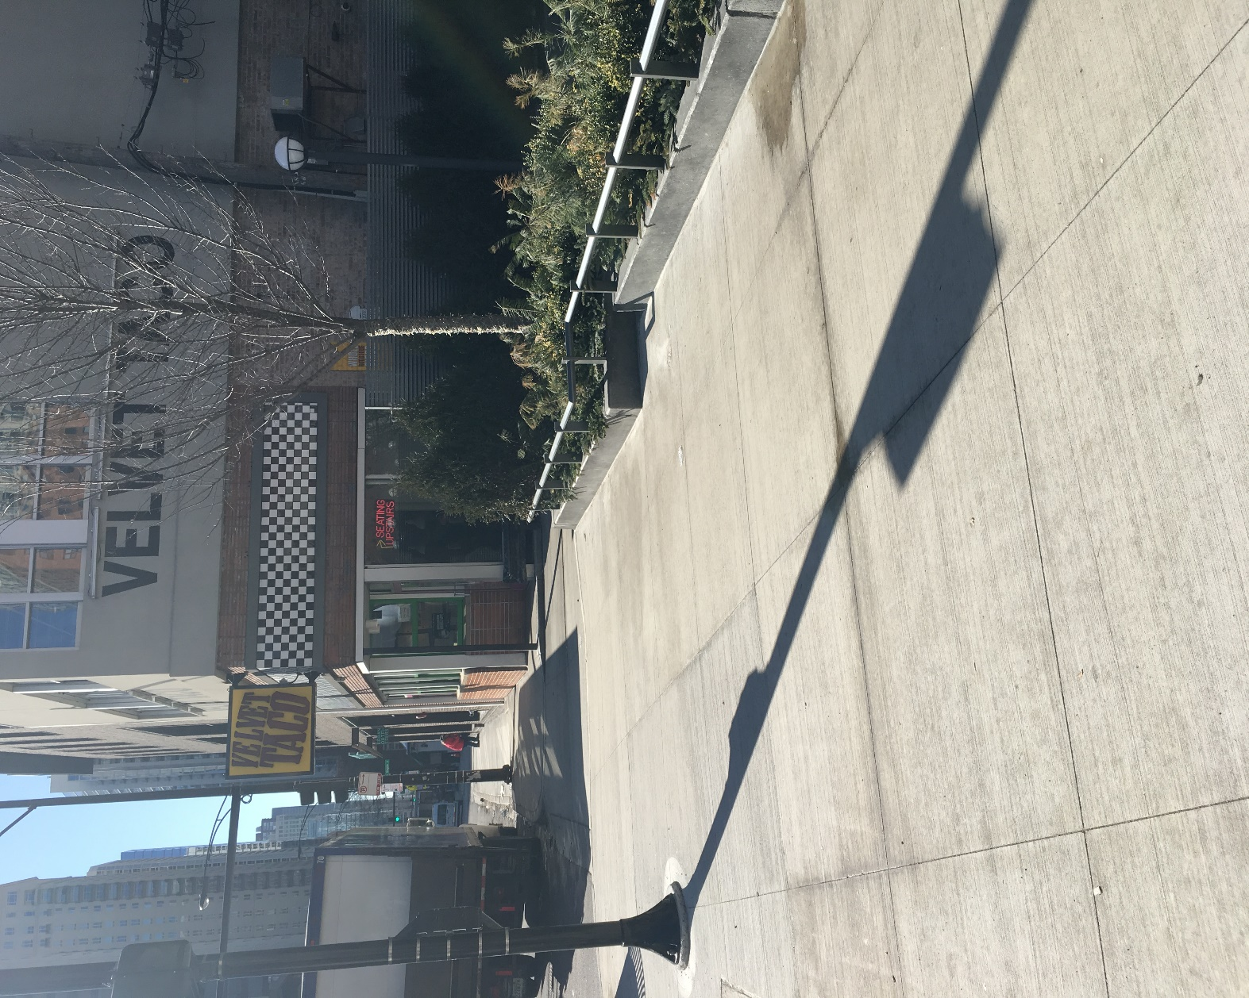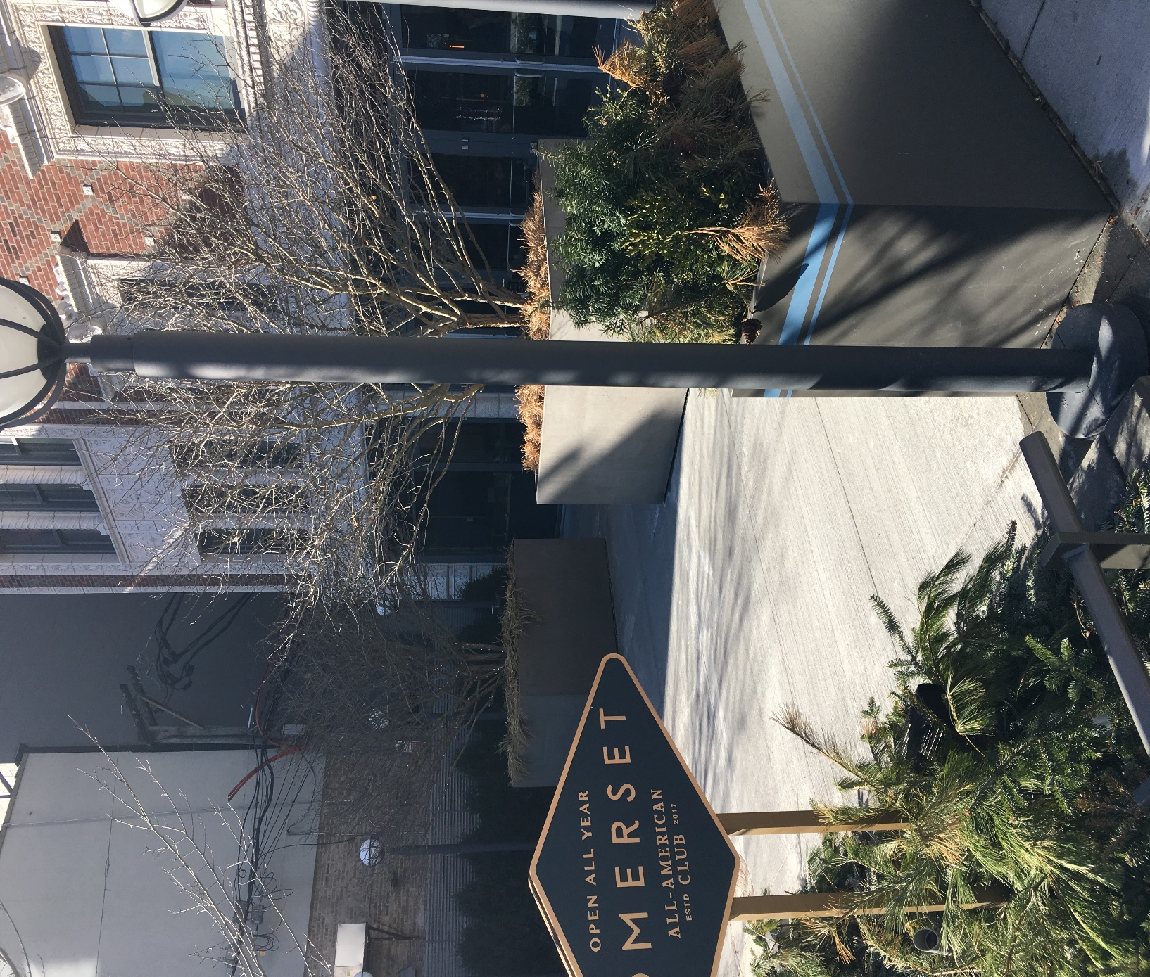

Renue’s Rapid Venue Restoration

Project details and costs for proposed cleaning

- Protect all glass and metal frames from chemical.
- Use caution cones to divide area being cleaned and caution motorist, pedestrians and guests of work being performed.
- Pre-treat all concrete with a high alkaline detergent for soiling deposits and an enzyme for the oil stains.
- Power wash all areas with 4000psi, heated, power washer to remove soiling.
- Vacuum up any standing water using a commercial wet/dry vac.

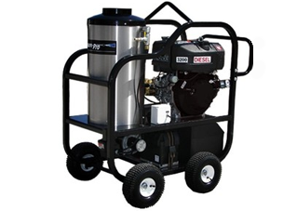
- Back alley from Mechanical Room door yellow pillars down to end of garage door (new concrete only)

Cost………………………………………………………………………..$850.00*
*Work to take place 1st shift

- Front of hotel from Lou Malnati’s down to alleyway just in front of Velvet Taco and includes Somerset Dinning Patio’s

Cost………………………………………………………………………..$1,100.00**
**Work to take place 3rd shift

PLEASE NOTE:

*48 hour cancellation notice required or a 15% cancellation fee will be charged.

*Hotel will allow us to use their water supply for this cleaning.

*Hotel to remove items from areas being cleaned prior to our scheduled cleaning. We can move light furniture from these areas.

*Hotel will provide complimentary parking during any scheduled work or cost will be billed back to the hotel.

Note some staining in the concrete and stone walls may be permanent and not removable with cleaning

Please complete this service agreement, sign it and return it to your local Renue Systems service provider.

Scope of Service:

Description: ________________________________________________________________
______________________________________________________________________________

Payment Terms:

The sum of $________________ is the agreed upon price for the services rendered with payment to made as follows:

____________ payments each for $___________ according to the following schedule:

______________________________________________________________________________

Please check here if your property will be paying by P-Card ___ or check ___

Card # _________________________ Card type _________________ Exp. date __________

3 Digit Security Code (back of card)____________________

We reserve the right to charge a credit card fee for a project paid by credit card exceeding $10,000

Acceptance of Service Agreement

The above pricing, specifications, terms and conditions are satisfactory and you are hereby authorized to commence the work as specified.

Name: _______________________________________________ Property:__________________________________

Signature: ____________________________________________ P.O. # (if needed):___________________________

Title: ________________________________________________ Date: _____________________________________

Phone: _______________________________________________ Email: ____________________________________

