William Garrett April 7, 2021
Manager of Operations
Thornton Township
High School D 205
465 East 170th, Street
South Holland, IL 60473

Garrett.William@district205.net
708-225-4087

Dear Mr. Garrett:

Thank you very much for the opportunity to earn your business. I am pleased to present to you this proposal for the deep restorative cleaning of various areas of the three back of house kitchens within High School District 205. Renue Systems can definitely help you achieve your goal of a perfectly spotless image to go along with your fantastic meals and service. If you have any questions regarding my proposal, please do not hesitate to call me.

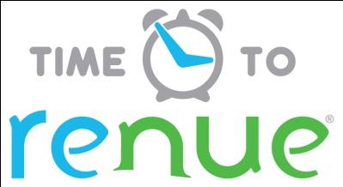

Why choose Renue Systems for your deep cleaning needs?

- We are the leading provider of comprehensive deep cleaning services in the Midwest and we have proudly serviced thousands of customers over our 30-year history
- We are the only company that has been a North America approved vendor of Avendra since its formation
- Expertly trained, certified and uniformed employees that specialize in working in professional environments
- Proprietary equipment and chemicals, well-tested methodologies and significant ongoing R&D to provide top results
- Extremely responsive scheduling and highly flexible payment plans to meet your changing needs – we work when it is convenient for you and on a 24/7 basis
- Easy to understand and transparent pricing – and all our work is 100% guaranteed to your satisfaction

Our Deep-Clean Process for your Commercial/Institutional Kitchen:

SCOPE OF WORK including options:

- Flooring
- Walls/doors/fixed shelving/surfacing
- Prep and wash station surfaces, drain grease traps
- Appliance and equipment caster wheels and legs
- Walk-ins
- Appliances

Pre-Spray surfaces with alkaline detergent specific for material to be cleaned to loosen soiling and staining.

Power Wash Clean appropriate surfaces and appliances using specialized 300 degree steam power and state-of-the-art rotary scrubbers delivering 1500 psi of hot water steam with cutting-edge starter detergents to accelerate soil release. Wash water is extracted via high-lift vacuum and never accumulates during our power washing.

Hand Clean countertops and vertical surfaces using specialty cleaning agents, tools and methods.

optional Deep Clean equipment and appliances including oven/steamer/heater racks and surfaces, fryer vats and backsplashes, range controls, burners and grates, grill controls, surfaces, and backsplashes using specialty chemicals, tools and professional industry methods.

Rinse and Neutralize floors and walls with a pH balance solution and clean steam-water rinse. This process removes any residue from cleaning agents and leaves the surfaces free from chemical build up. Rinse water is extracted via high-lift vacuum and never accumulates during our rinsing. Equipment and other surfaces may be hand rinsed.

optional Sanitize and Disinfect all high-touch surfaces and food preparation areas using the Clorox Total 360 electrostatic disinfection system.
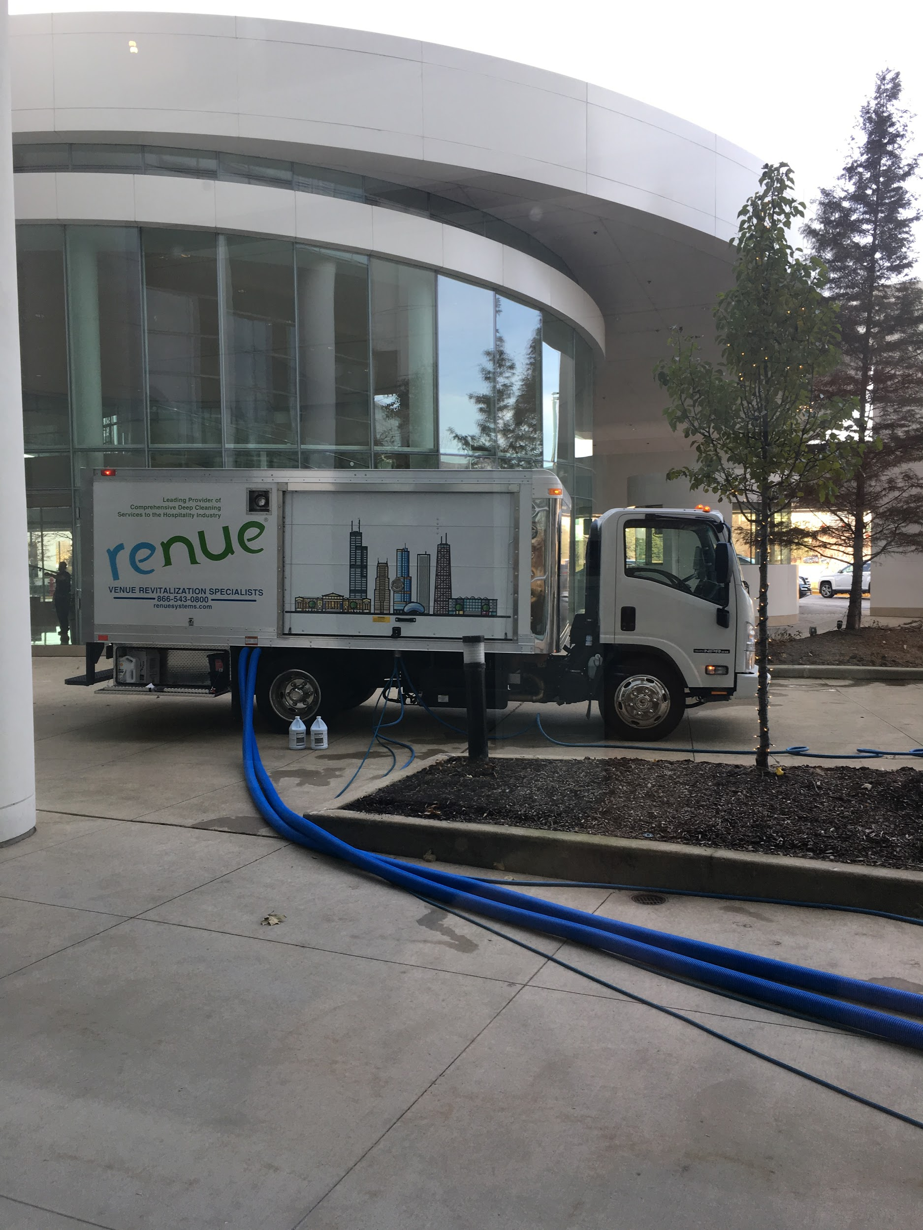

Project Details and Costs for Proposed Deep-Cleaning Services:

Thornwood HS Kitchen (Back of House BoH)
- Main Kitchen/Open Storage
- Serving Areas
- Dry Storage
- Locker Room/Restroom
- Office/Mop Closet

Thornwood BoH Floors $2,560
Option to add Walls, Drains, Base Molding, and Surfaces $1,600
Option to add Appliances $2,240
Option to add Electrostatic Sanitizing and Disinfecting $640
Option to add Walk-in Cold Storage $245/each

Thornton Township HS Kitchen (Back of House BoH)
- Main Kitchen/Open Storage
- Serving Areas
- Dry Storage
- Locker Room/Restroom
- Office/Mop Closet

Thornton Township BoH Floors $2,340
Option to add Walls, Drains, Base Molding, and Surfaces $1,450
Option to add Appliances $2,050
Option to add Electrostatic Sanitizing and Disinfecting $590
Option to add Walk-in Cold Storage $245/each

Thornridge HS Kitchen (Back of House BoH)
- Main Kitchen/Open Storage
- Serving Areas
- Dry Storage
- Locker Room/Restroom
- Office/Mop Closet

Thornridge BoH Floors $1,590
Option to add Walls, Drains, Base Molding, and Surfaces $1,140
Option to add Appliances $1,550
Option to add Electrostatic Sanitizing and Disinfecting $400
Option to add Walk-in Cold Storage $245/each

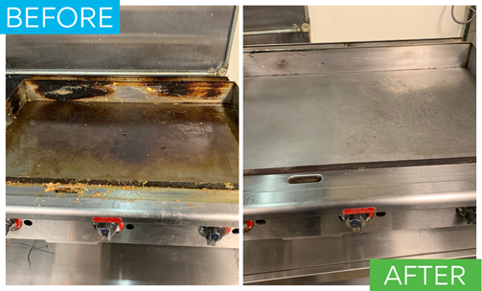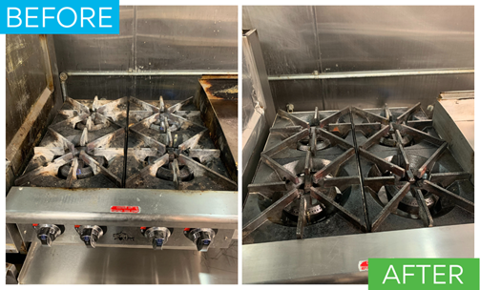

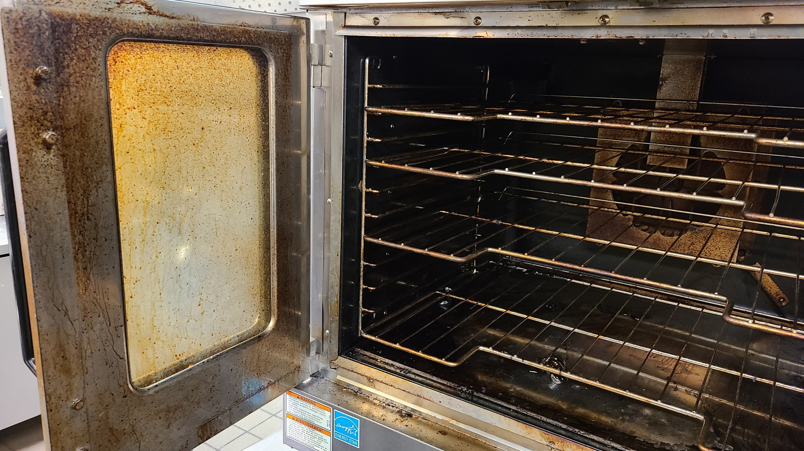
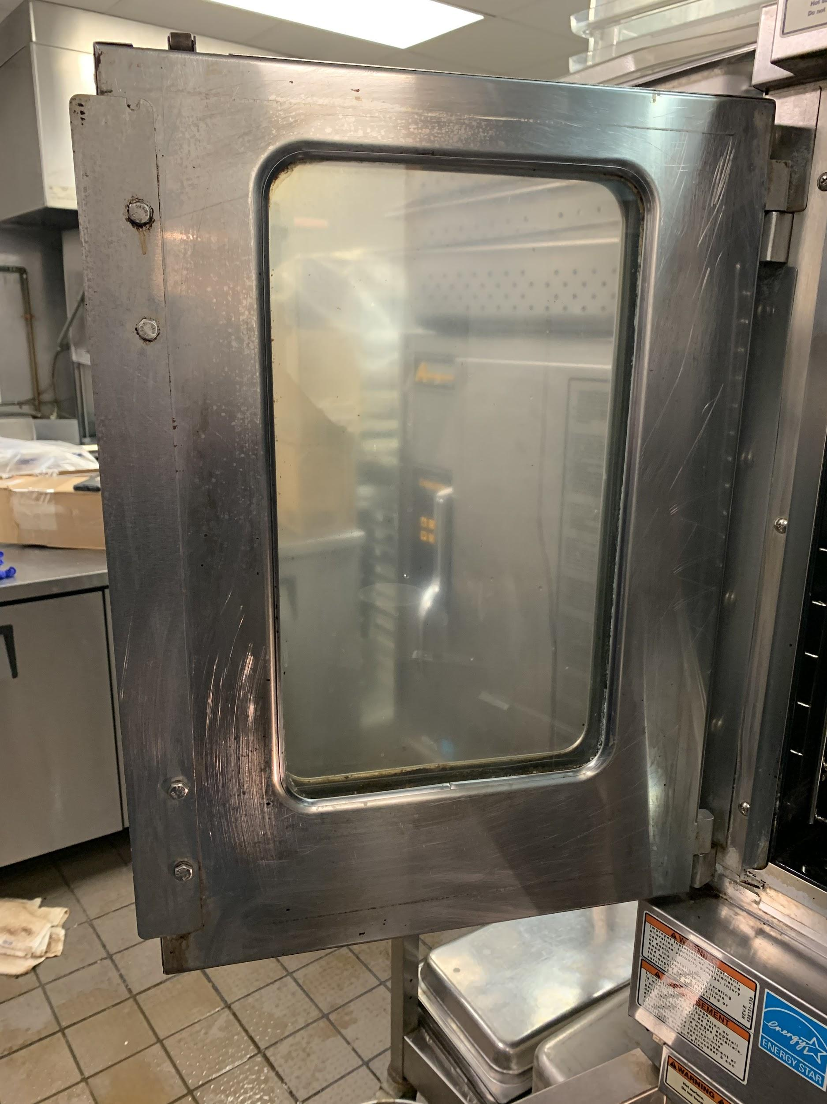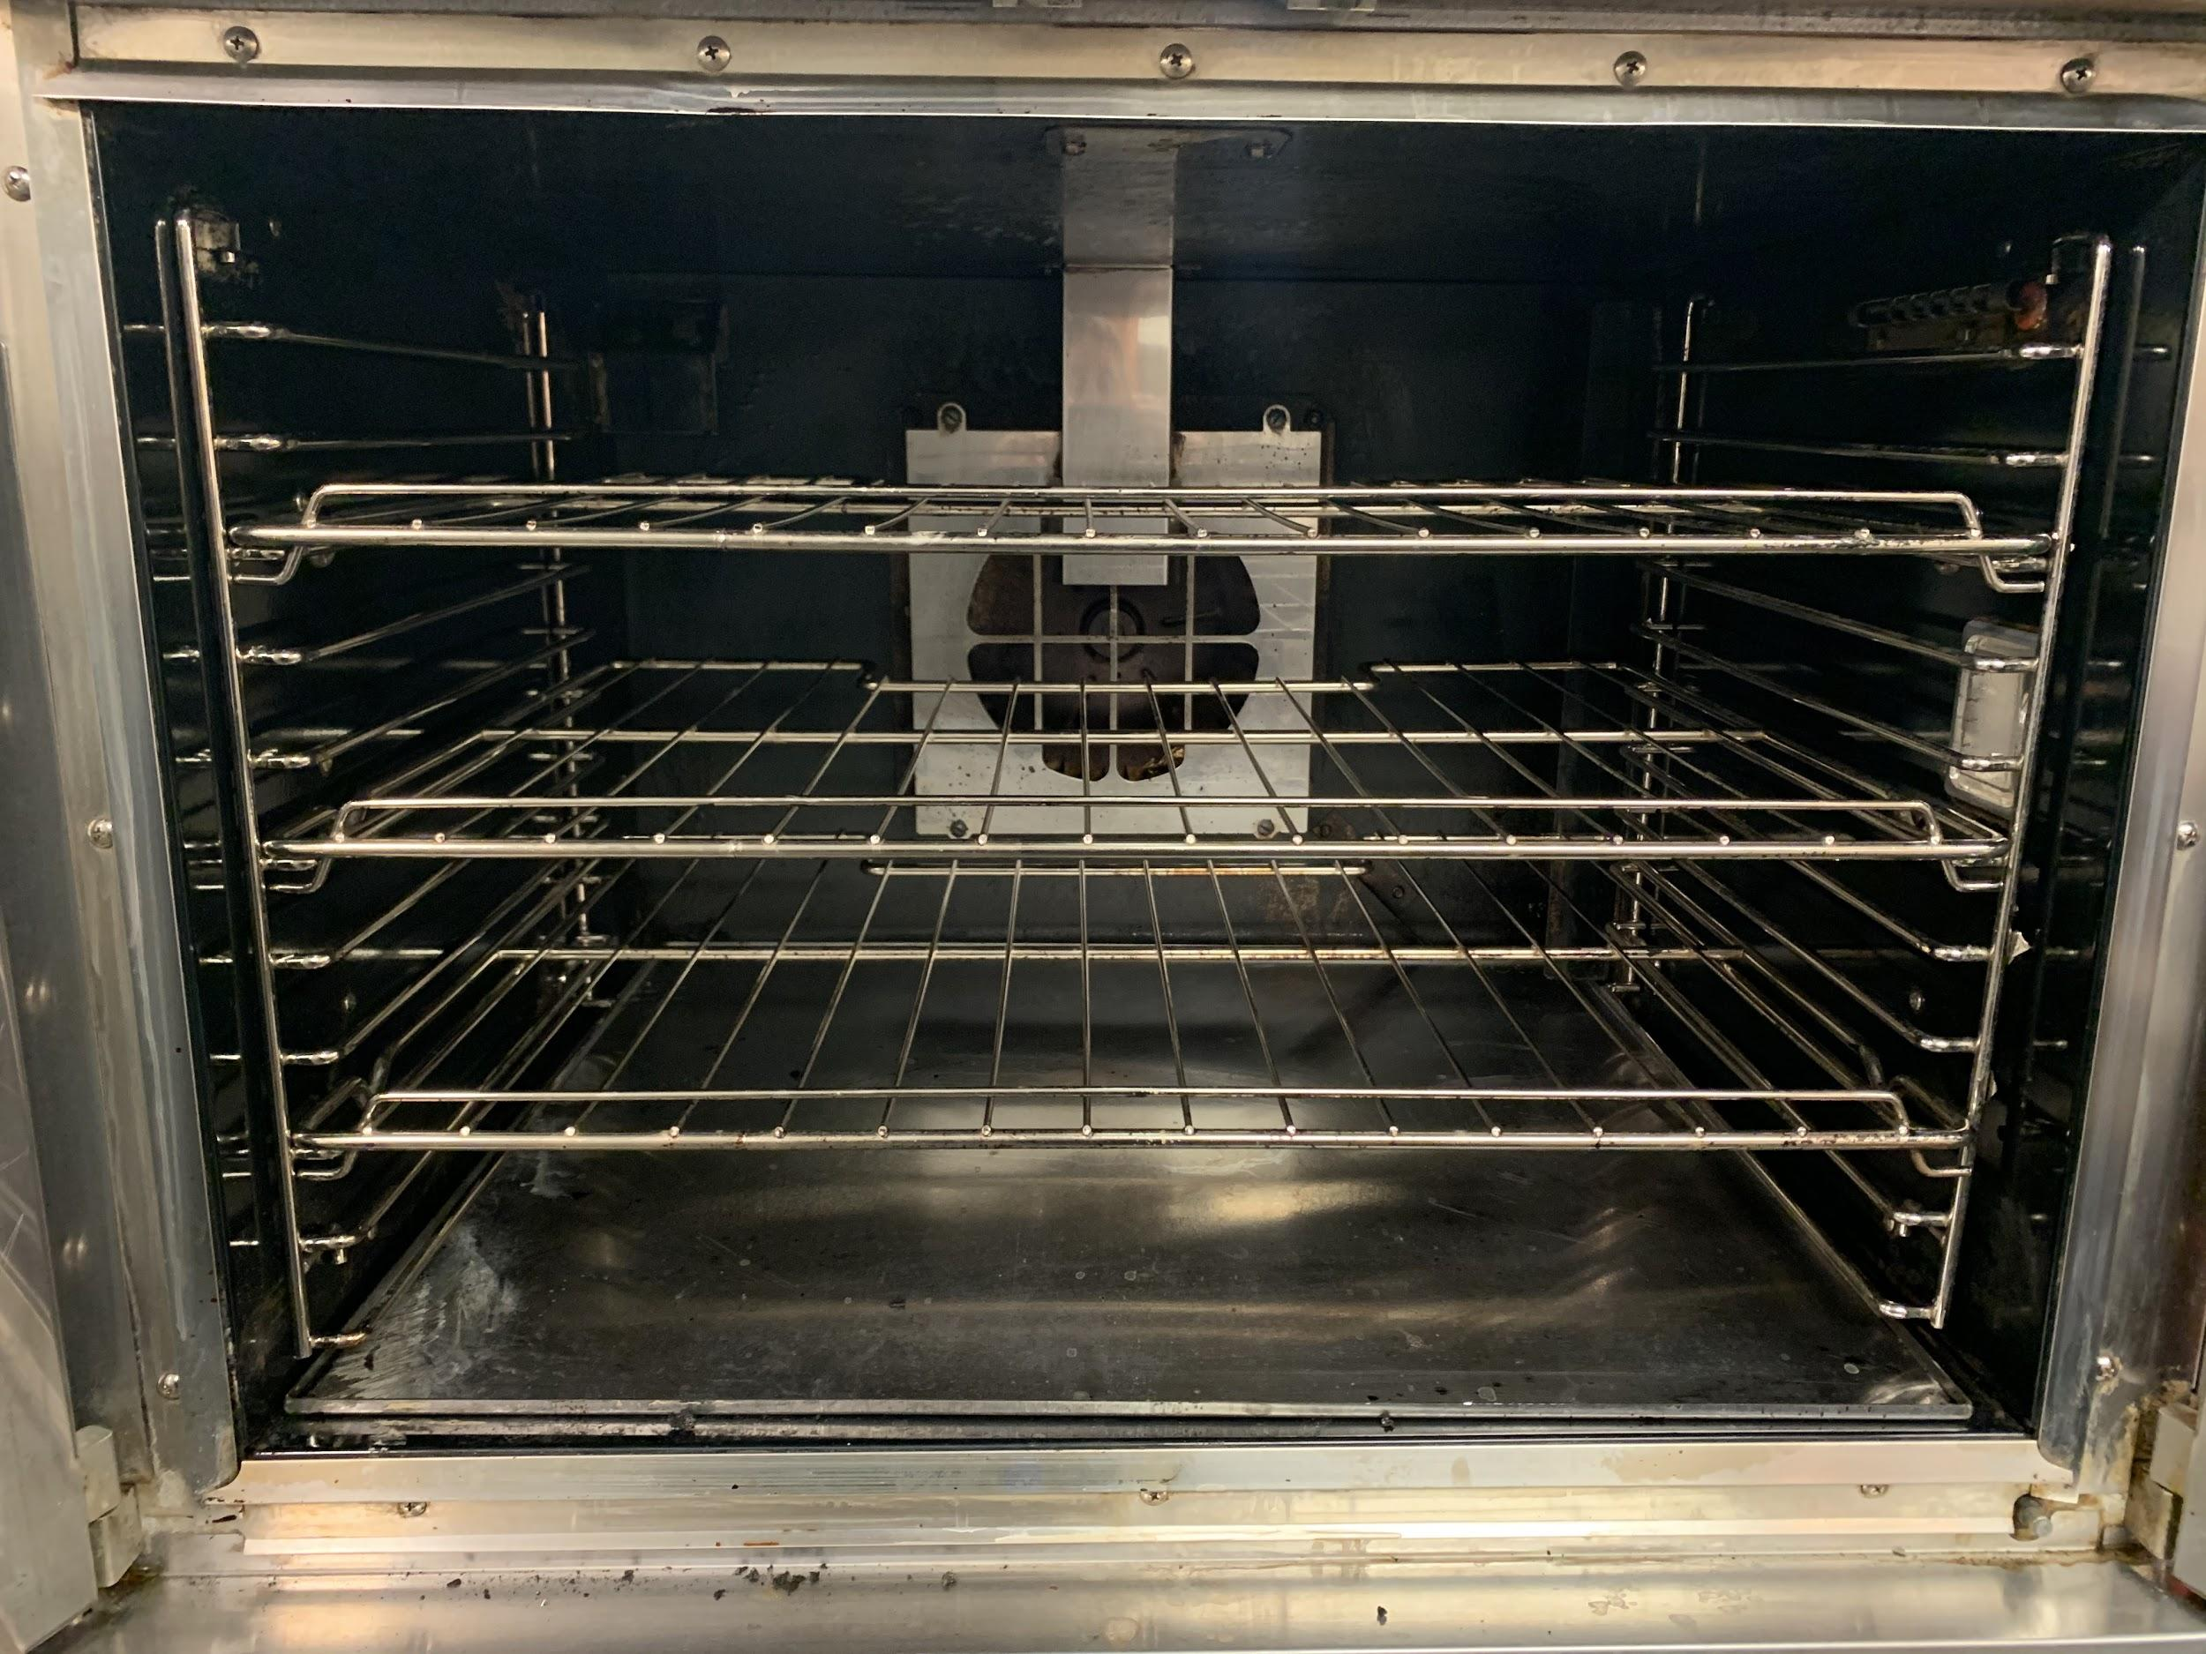

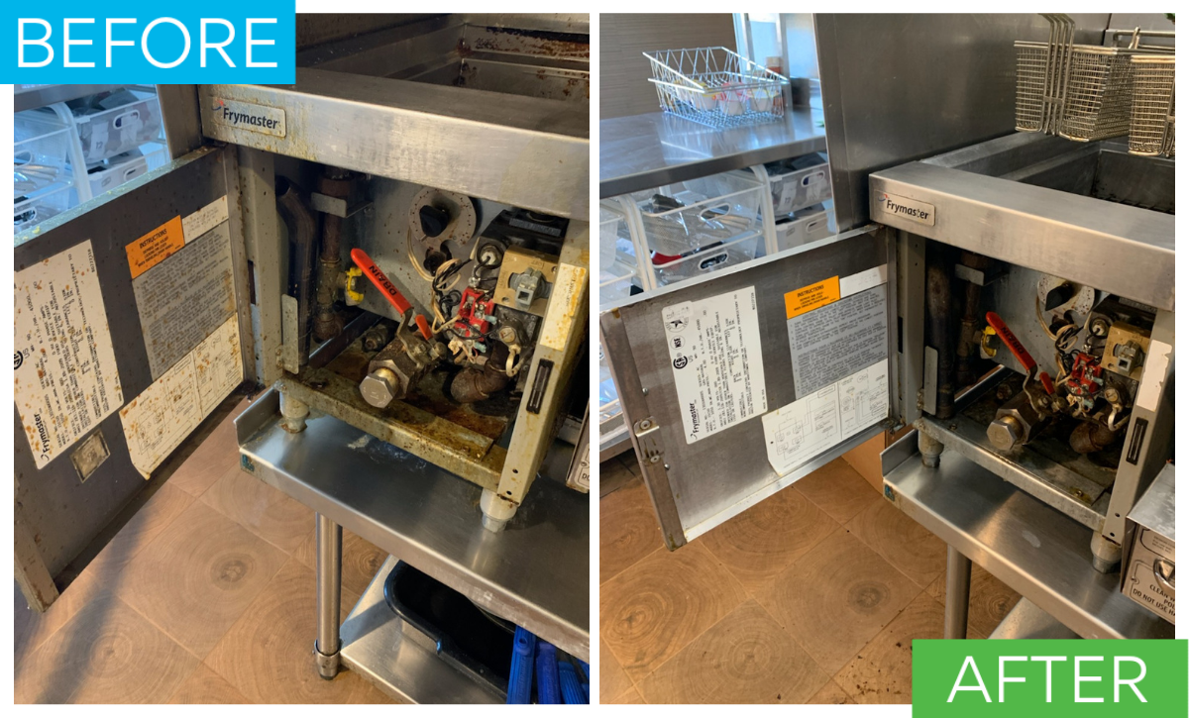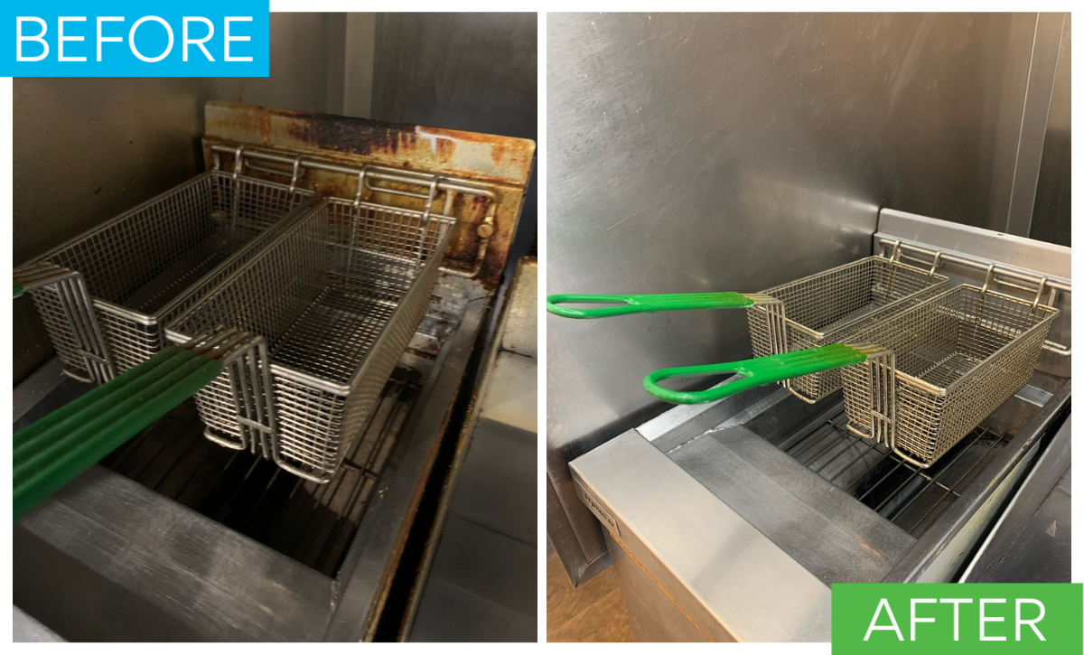

PLEASE NOTE:

*48-hour cancellation notice required or a 15% cancellation fee will be charged.
*This service is cleaning only and not a preventive maintenance service for any equipment or appliances.
*Renue Systems requires a $450 minimum charge per visit. This is not an extra charge and NOT in addition to the cost of scheduled work.
*Cleaning of kitchen hoods, ductwork, or blower/fans are not included in this proposal.
*Preventive maintenance/cleaning of ice machines and beverage makers/dispensers is not included in this proposal.
*Cold storage preventive maintenance is not included in this proposal.
*Counters, shelves, and rack will only be included in the cleaning if emptied and clear of items.
*Appliances that have items inside of them will be exterior surfaces cleaned only.
*Freezer appliances and walk in interiors will only be cleaned if defrosted and above 37 degrees)
*Above pricing does not include moving fixed or large equipment.
*Above pricing does not include cleaning of any prep, cooking, or serviceware items.
*Some staining in the surfaces may be permanent and not removable with cleaning.

Renue Systems will not be responsible for the following (but we can address):
- Compromised or missing grout
- Chipped or cracked tiles
- Previously waxed tile and grout
- Flooring where grout lines have been painted and are not the original grout color
- Uneven surface coloring and cracks may be evident after floor is cleaned and free of sealer/wax and other coatings

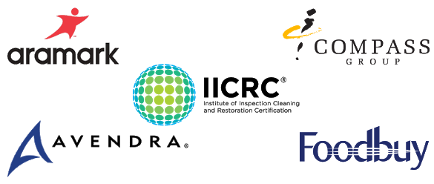

Please complete this service agreement and return it to Renue Systems.

Scope of Service:

Description: ________________________________________________________________

______________________________________________________________________________

Payment Terms:

The sum of $_________________________ is the agreed upon price for the services proposed in this agreement and attached proposal.

______________________________________________________________________________

Please check here if paying by Credit Card (3% fee added)____ or check ____

Card # _________________________ Card type _________________ Exp. date __________

3 Digit Security Code (back of card)____________________

Acceptance of Service Agreement

The above pricing, specifications, terms and conditions are satisfactory and Renue Systems is hereby authorized to commence the work as proposed and described.

Name: _______________________________________________ Property:__________________________________

Signature: ____________________________________________ P.O. # (if needed):___________________________

Title: ________________________________________________ Date: _____________________________________

Phone: _______________________________________________ Email: ____________________________________

