Tim Regan October 26, 2018
Director of Housekeeping
Hotel Monaco
225 N. Wabash
Chicago, IL 60601

Email: tim.regan@hotelmonaco.com

Dear Mr. Regan:

We are pleased to present you this proposal for the MORE™ AntiEtch™ system . After examining your property and discussing your needs, I have prepared the service outline below. If you have any questions regarding my proposal, please do not hesitate to call me.

Why choose Renue Systems for your deep cleaning needs?

- We are the leading provider of comprehensive deep cleaning services exclusively to the hospitality industry – we have proudly serviced thousands of hotels over our 30 year history
- We are the only company that has been a North America approved vendor of Avendra since its formation
- Expertly trained, certified and uniformed employees that specialize in working in the hotel environment – no micromanaging of our team by your team is needed
- Proprietary equipment and chemicals, well-tested methodologies and significant ongoing R&D to provide top results
- Extremely responsive scheduling and highly flexible payment plans to meet your changing needs – we work when it is convenient to you and on a 24/7 basis
- Easy to understand and transparent pricing – and all our work is 100% guaranteed to your satisfaction

Renue Systems is a Certified Applicatior of the MORE™ AntiEtch™ system.

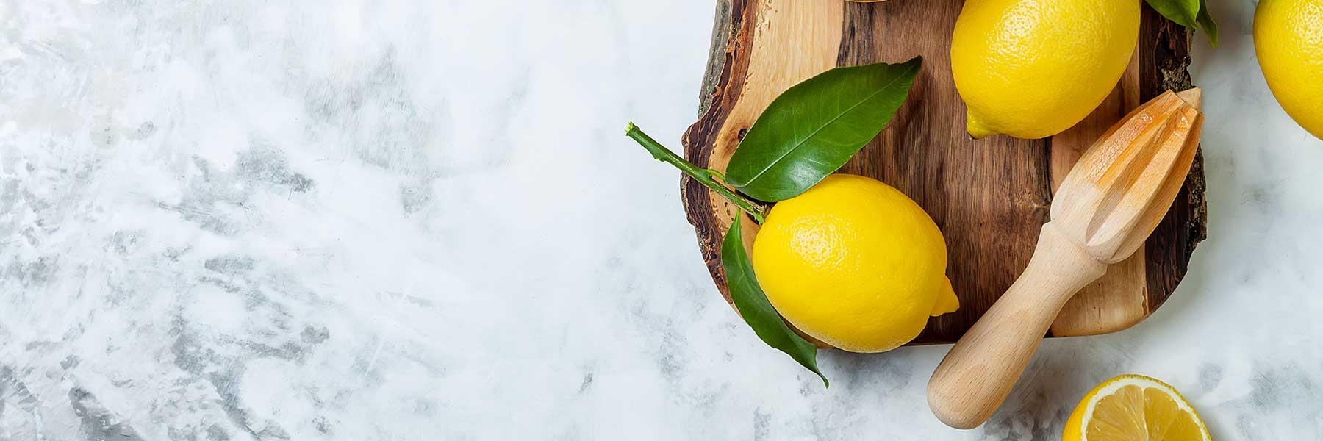

MORE™ AntiEtch™ will stop etching and staining caused by acidic foods and liquids. This innovative solution forms a durable, ultra-low visibility, super-thin, coating that prevents the toughest stains and caustic solutions from coming in contact with your marble countertop surface.

Features and benefits of MORE™ AntiEtch™ :

- Stops etching and staining.
- Crystal clear finish. Almost invisible to the eye.
- Can be applied on marble, limestone, onyx, travertine, and concrete.
- Can be applied to honed and polished surfaces. High gloss and matte finishes available.
- Can be applied to both horizontal and vertical surfaces.
- Low odor during application.
- Environmentally friendly.
- Safe on food-contact surfaces.
- Zero porosity - germs and bacteria have nowhere to grow.
- Will not crack or peel.
- Easy to maintain and repair.
- Durable - 10 years expected wear.

The More AntiEtch Protective process:

At your property we will perform the following methodology, a well-tested technique by More AntiEtch developed over the years in conjunction with the leading marblecare restoration association:

Step #1: PROTECT all adjacent areas that we won’t be treating. Place caution cones and wet floor signs around work area to warn customers and employees of any potential slip and fall hazards in the immediate work area.

Step #2: PREP marble or natural stone by removing any caulking, protect any joints in slabs and begin honing surface with an 80 or 100 grit diamond tool (grit is a measure of abrasiveness). Hone all edges or corners using a specialized tool for those uneven surfaces.

Step #3: CLEAN areas with IPA or Acetone and microfiber cloth. Wipe area with tact cloth.

Step #4: APPLY More AntiEtch self-leveling coating with brushes and rollers. Let stand 15 minute before proceeding.

Step #5: CURE More AntiEtch self-leveling coating with the More Energy Cure UV Light.
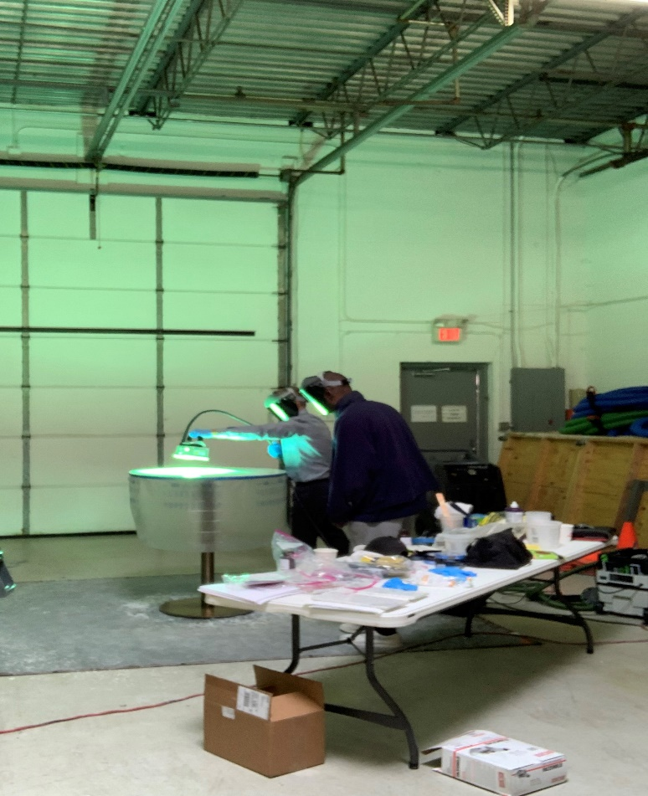

Step #6: HONE & POLISH the MORE AntiEtch protective coating with 240, 320, 400, 600, 800, 1000, 1500, 2000 grit diamonds and 3M 5000 Trizact diamond pad.

Step #7: APPLY a unique polishing compound and polish to the desired level of gloss.

Step #8: RE-CLEAN areas with a tact cloth.

The final result is an etch proof surface ready for your guests!

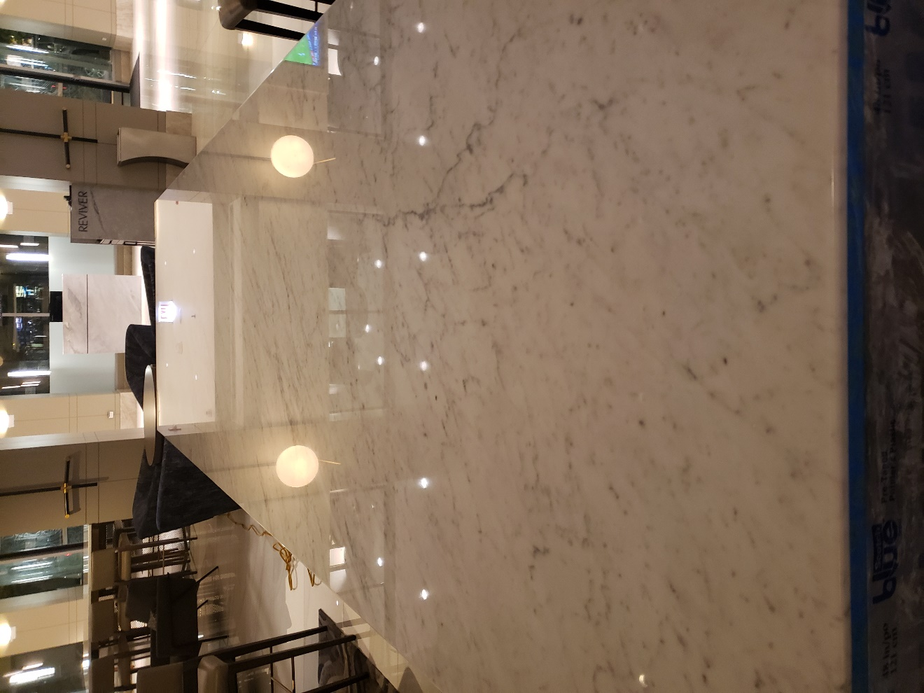

Pricing for the MORE™ AntiEtch™ System installed:

6 tables in bar area

Total……………………...……………………………………………………$2,500.00

Suggested Maintenance:

- Use a neutral pH cleaner.
- Use disinfecting cleaners or isopropyl alcohol (rubbing alcohol) for sanitizing.
- DO NOT use abrasive cleaners or scrub pads to clean surface. Remember, your new surface is etch proof not scratch proof.
- Follow the Stone Institute of America, Marble Institute of America guidelines for proper care and maintenance of marble and other natural stones.

We will be glad to afford you payment terms to work within your budget.

PLEASE NOTE

Renue Systems will not be responsible for the following (but can address):

- Chipped or cracked areas in the stone
- Filling of mineral deposit holes in stone unless previously specified
- Compromised or missing grout
- Uneven surface coloring
- Permanent stains in the stone and grout
- Deep scratches may not be completely removed. Impact marks that appear to be scratches are bruises in the stone that cannot be removed with restoration
- Price does not include repairs or replacement of any areas that are caulked

*48 hour cancellation notice required or a 15% cancellation fee will be charged.

*Hotel will provide complimentary parking during any scheduled work or cost will be billed back to the hotel.
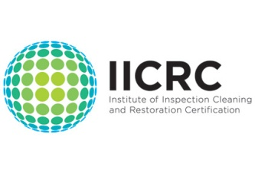
APPROVED VENDOR
Please complete this service agreement, sign it and return it to your local Renue Systems service provider.

Scope of Service:

Description: ________________________________________________________________

______________________________________________________________________________

Payment Terms:

The sum of $________________ is the agreed upon price for the services rendered with payment to made as follows:

____________ payments each for $___________ according to the following schedule:
______________________________________________________________________________

Please check here if your property will be paying by P-Card ___ or credit card ___

Card # _________________________ Card type _________________ Exp. date __________

3 Digit Security Code (back of card):______________

Acceptance of Service Agreement

We reserve the right to charge a credit card fee for a project paid by credit card exceeding $10,000

The above pricing, specifications, terms and conditions are satisfactory and you are hereby authorized to commence the work as specified.

Name: _______________________________________________ Property:__________________________________

Signature: ____________________________________________ P.O. # (if needed):___________________________

Title: ________________________________________________ Date: _____________________________________

Phone: _______________________________________________ Email: ____________________________________

