Rick Belluomini May 9, 2013
Director of Engineering
Sheraton Elk Grove
121 NW Point Blvd.
Elk Grove Village, IL 60007

Email: rbelluomini@sheratonchicagoelkgrove.com

Dear Mr. Belluomini,

Thank you very much for the opportunity to earn your business. We are pleased to present you this proposal for bleach stain repair of your carpets. If you have any questions regarding my proposal, please do not hesitate to call me.

Why choose Renue Systems for your deep cleaning needs?

- We are the leading provider of comprehensive deep cleaning services exclusively to the hospitality industry – we have proudly serviced thousands of hotels over our 30 year history
- We are the only company that has been a North America approved vendor of Avendra since its formation
- Expertly trained, certified and uniformed employees that specialize in working in the hotel environment – no micromanaging of our team by your team is needed
- Proprietary equipment and chemicals, well-tested methodologies and significant ongoing R&D to provide top results
- Extremely responsive scheduling and highly flexible payment plans to meet your changing needs – we work when it is convenient to you and on a 24/7 basis
- Easy to understand and transparent pricing – and all our work is 100% guaranteed to your satisfaction

Renue’s Rapid Color Restoration
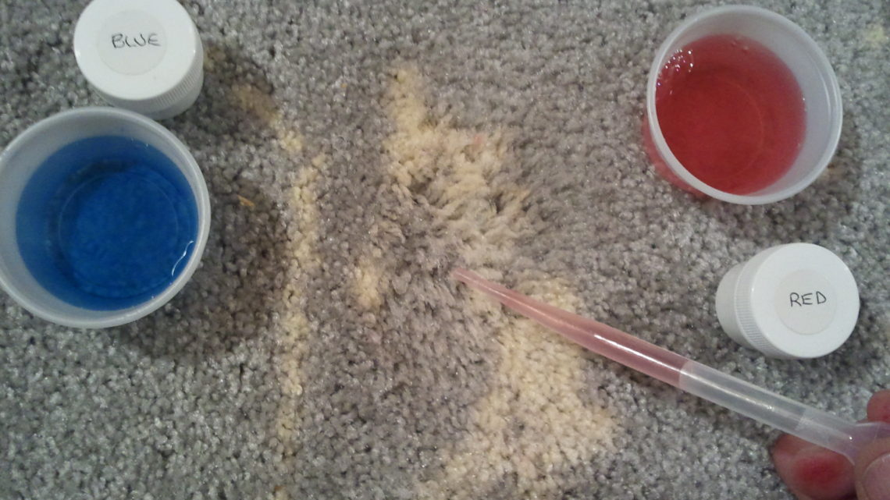

Carpet Dyeing process description:

This process for the restoration of spots in carpeting that have a change/loss of color and fiber damage due to a bleaching (oxidizing agent) agents is a time consuming and delicate one. The amount of color change/loss and damage is dependent on many variables that include the amount of material spilled and how long it’s been on the carpeting. Once it is determined what colors are missing and that the carpet fibers will accept a dye solution, liquid dye baths are made and heated to over 180 degrees. Then the hot liquid dye is applied to the individual carpet tufts literally with an eyedropper, one drop at a time. In this way, the pattern is reconstructed slowly and carefully until the entire section is restored. Some spots may have excessive damage from the bleaching agent and therefore may accept only a portion of the coloring agent and dyes. Results can vary from spot to spot.

Project details and costs for proposed cleaning

- Spot dyeing in the following areas:

Stairs from 7th to 8th floors, in front of stairs going from 7th to 8th floors and in front of room #’s- 207, 317, 411, 521, 513, 601& 709.

Cost…………………………………………………………….$600.00

PLEASE NOTE:

*48 hour cancellation notice required or a 15% cancellation fee will be charged.

*Renue Systems requires a $375.00 minimum service call charge per visit. This is NOT in addition to any scheduled work.

*Some carpet fibers may be permanent damaged and new dyes introduced to those areas may a limited effect.

Please complete this service agreement, sign it and return it to your local Renue Systems service provider.

Scope of Service:

Description: ________________________________________________________________

______________________________________________________________________________

Payment Terms:

The sum of $________________ is the agreed upon price for the services rendered with payment to made as follows:

____________ payments each for $___________ according to the following schedule:
______________________________________________________________________________

Please check here if your property will be paying by P-Card ___ or check ___

Card # _________________________ Card type _________________ Exp. date __________

3 Digit Security Code (back of card)____________________

Acceptance of Service Agreement

The above pricing, specifications, terms and conditions are satisfactory and you are hereby authorized to commence the work as specified.

Name: _______________________________________________ Property:__________________________________

Signature: ____________________________________________ P.O. # (if needed):___________________________

Title: ________________________________________________ Date: _____________________________________

Phone: _______________________________________________ Email: ____________________________________

