Nick Hefner October 22, 2018
General Manager

Town Place Suites
455 E. 22nd Street
Lombard, IL 60148

Email: nick.hefner@marriott.com

Dear Nick,

Thank you very much for interest in the services we provide to the hospitality industry. We are pleased to present you this proposal for the cleaning of your VTAC units. If you have any questions regarding my proposal, please do not hesitate to call me.

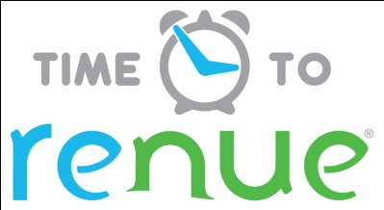

Why choose Renue Systems for your deep cleaning needs?

- We are the leading provider of comprehensive deep cleaning services exclusively to the hospitality industry – we have proudly serviced thousands of hotels over our 30 year history
- We are the only company that has been a North America approved vendor of Avendra since its formation
- Expertly trained, certified and uniformed employees that specialize in working in the hotel environment – no micromanaging of our team by your team is needed
- Proprietary equipment and chemicals, well-tested methodologies and significant ongoing R&D to provide top results
- Extremely responsive scheduling and highly flexible payment plans to meet your changing needs – we work when it is convenient to you and on a 24/7 basis
- Easy to understand and transparent pricing – and all our work is 100% guaranteed to your satisfaction

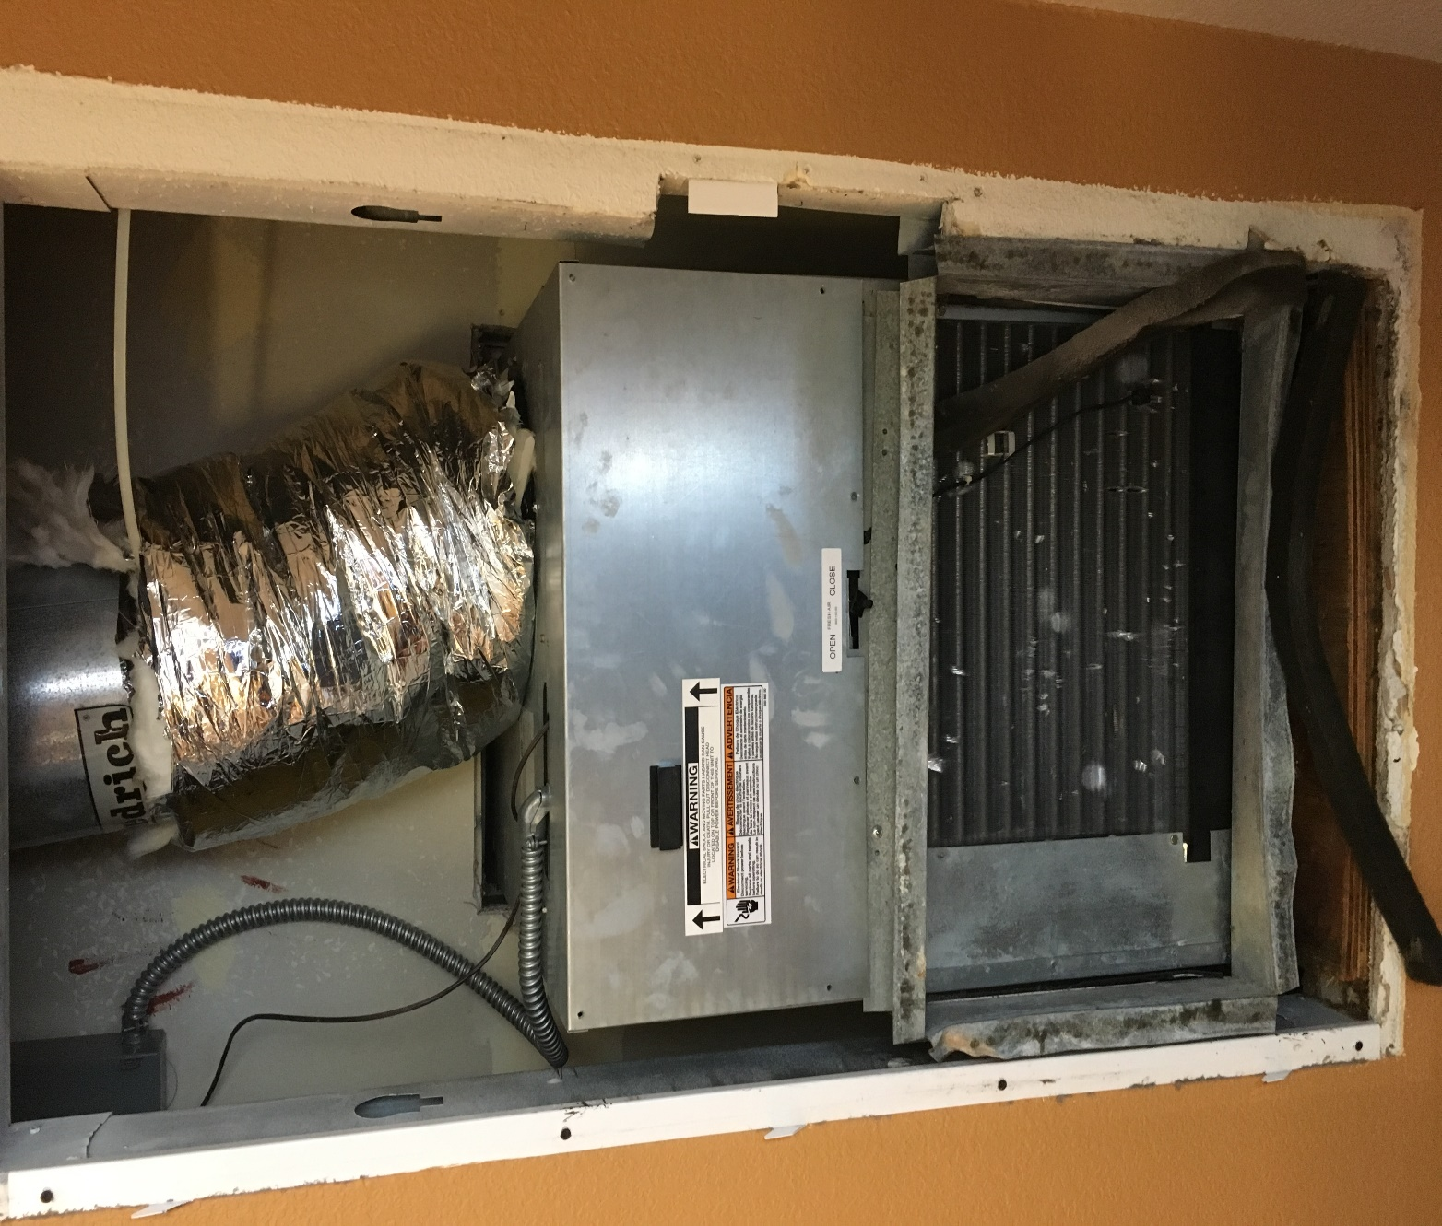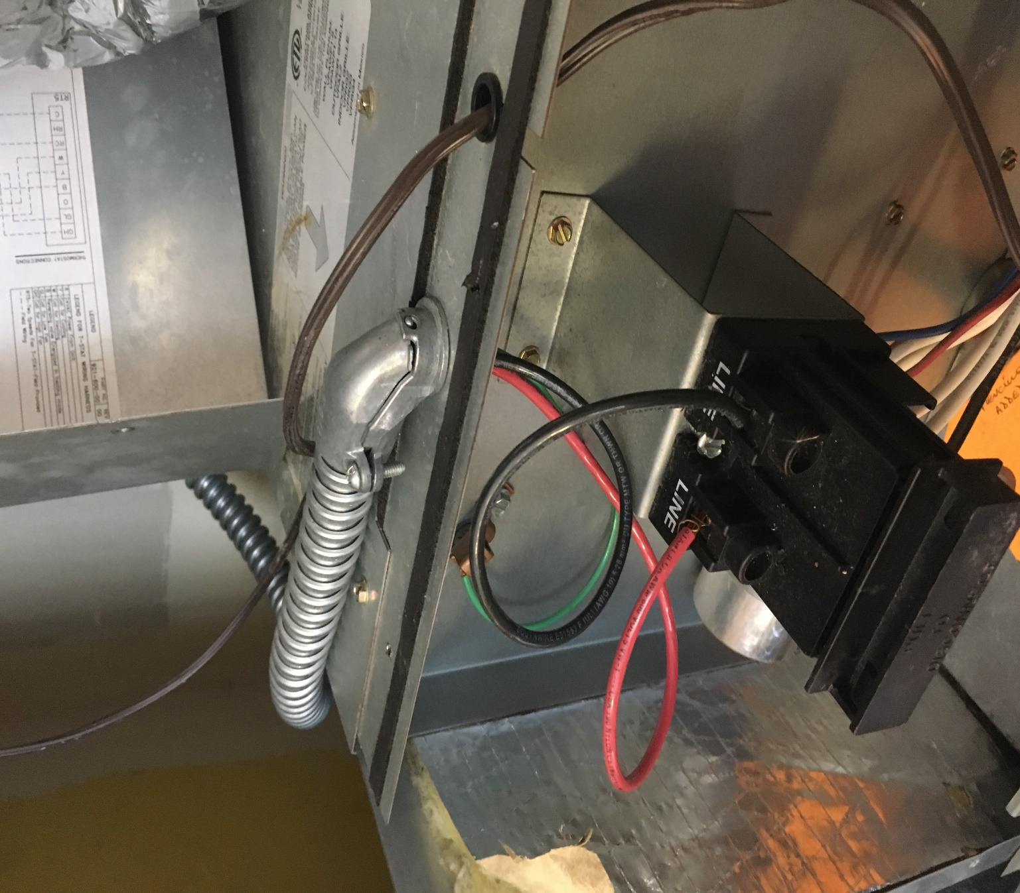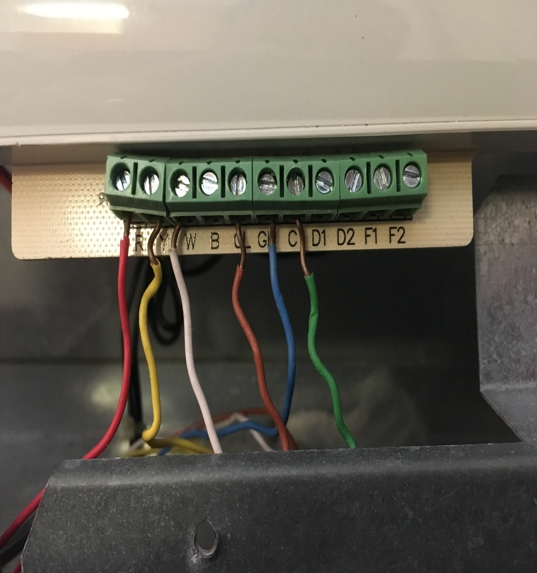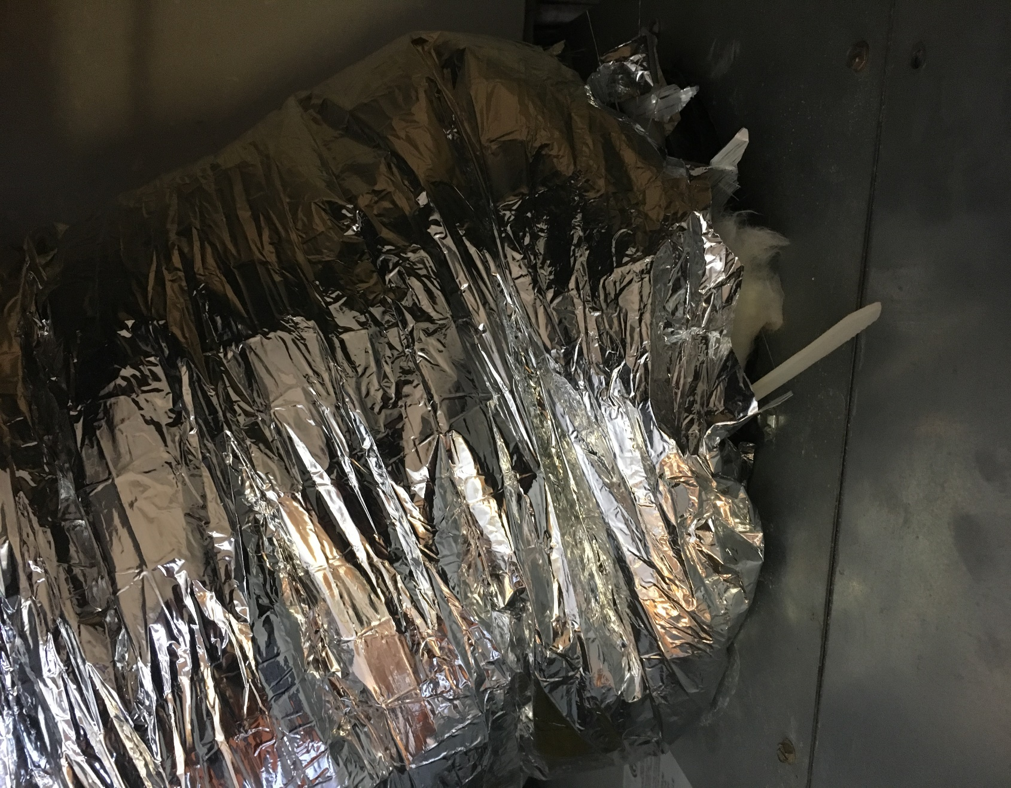

Project details and cost for cleaning of VTAC units

Units to be removed from closet and cleaned outside

- Shut off wall thermostat.
- Turn off circuit breaker in room or have engineering confirm power is shut off to unit.
- Hotel engineer to removal electrical wiring.
- Cut zip ties at duct work or unscrew sheet metal screws and move ducts to the side.
- Remove all low voltage wiring from thermostat.
- Slide unit out and disconnect drain line.
- Place on dolly and transport outside hotel for cleaning.
- Remove side panels to access catch pan and back side of coils as well as blower wheel.
- Cover any control or circuit boards with plastic to protect against them getting accidently wet during the cleaning process.
- Clean coils, blower wheel and catch pan using a low pressure spray and Simply Green cleaning solution.
- Vacuum up all standing water and debris.
- Transport unit back to the room for reinstallation.
- Clean drain lines in VTAC cabinet or closet before installing unit. This will be done using compressed air or pressurized water.
- Check any seals or gaskets and replace if needed. Hotel to provide all necessary hardware needed.
- Install unit back into closet or cabinet.
- Reinstall all duct work using new zip ties or sheet metal screws and align unit over drain lines.
- If filters are provided by the property, we will change each one out as we do our service.
- Clean any debris up around the unit. Clean and vacuum vent in door and all surrounding areas in and around base of unit.
- Hotel engineer to hook back up any electrical wiring.
- The unit will be tested to insure that it is operating properly.
- Property management to inspect random units to confirm the quality of the cleaning.
Cost-

30 units cleaned as described above……………………………………..$4,800.00*

*We estimate each unit taking about 1:45 minutes to remove, clean as described and reinstall after meeting with your property engineer. We also estimate completing 7-8 units each day with a 3 man crew. Project should take a total of 4 days to complete.

Property to also provide extra screws for Renue to replace any that are missing.

PLEASE NOTE:

*48 hour cancellation notice required or a 15% cancellation fee will be charged.

*Renue Systems requires a $375.00 minimum service call charge per visit. This is NOT in addition to any scheduled work.

*Hotel will provide access to guestrooms in a contiguous fashion to Renue System technicians during scheduled cleaning.

*Hotel to provide complimentary parking during any scheduled work or cost for that will be billed back to the hotel.

*Pricing does NOT include any biocide tablets. We can add this option for a small cost but please inform us of your desire beforehand.

We will be glad to afford you payment terms to work within your budget

APPROVED VENDOR

Please complete this service agreement, sign it and return it to your local Renue Systems service provider.

Scope of Service:

Description: ________________________________________________________________

______________________________________________________________________________

Payment Terms:

The sum of $________________ is the agreed upon price for the services rendered with payment to made as follows:

____________ payments each for $___________ according to the following schedule:
______________________________________________________________________________

Please check here if your property will be paying by P-Card ___ or check ___

Card # _________________________ Card type _________________ Exp. date __________

3 Digit Security Code (back of card)____________________

We reserve the right to charge a credit card fee for a project paid by credit card exceeding $10,000

Acceptance of Service Agreement

The above pricing, specifications, terms and conditions are satisfactory and you are hereby authorized to commence the work as specified.

Name: _______________________________________________ Property:__________________________________

Signature: ____________________________________________ P.O. # (if needed):___________________________

Title: ________________________________________________ Date: _____________________________________

Phone: _______________________________________________ Email: ____________________________________

