Gretchen Ingwersen November 4, 2015
Senior F&B Operations Manager
Marriott Oak Brook
1401 W. 22nd Street
Oakbrook, IL 60523

Email: gretchen.ingwersen@marriott.com

Thank you very much for the opportunity to earn your business. We are pleased to present you this proposal for the restoration cleaning of your air walls. If you have any questions regarding my proposal, please do not hesitate to call me.

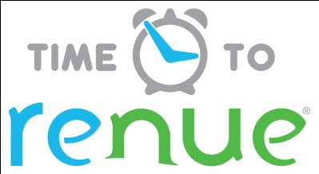

Why choose Renue Systems for your deep cleaning needs?

- We are the leading provider of comprehensive deep cleaning services exclusively to the hospitality industry – we have proudly serviced thousands of hotels over our 30 year history
- We are the only company that has been a North America approved vendor of Avendra since its formation
- Expertly trained, certified and uniformed employees that specialize in working in the hotel environment – no micromanaging of our team by your team is needed
- Proprietary equipment and chemicals, well-tested methodologies and significant ongoing R&D to provide top results
- Extremely responsive scheduling and highly flexible payment plans to meet your changing needs – we work when it is convenient to you and on a 24/7 basis
- Easy to understand and transparent pricing – and all our work is 100% guaranteed to your satisfaction

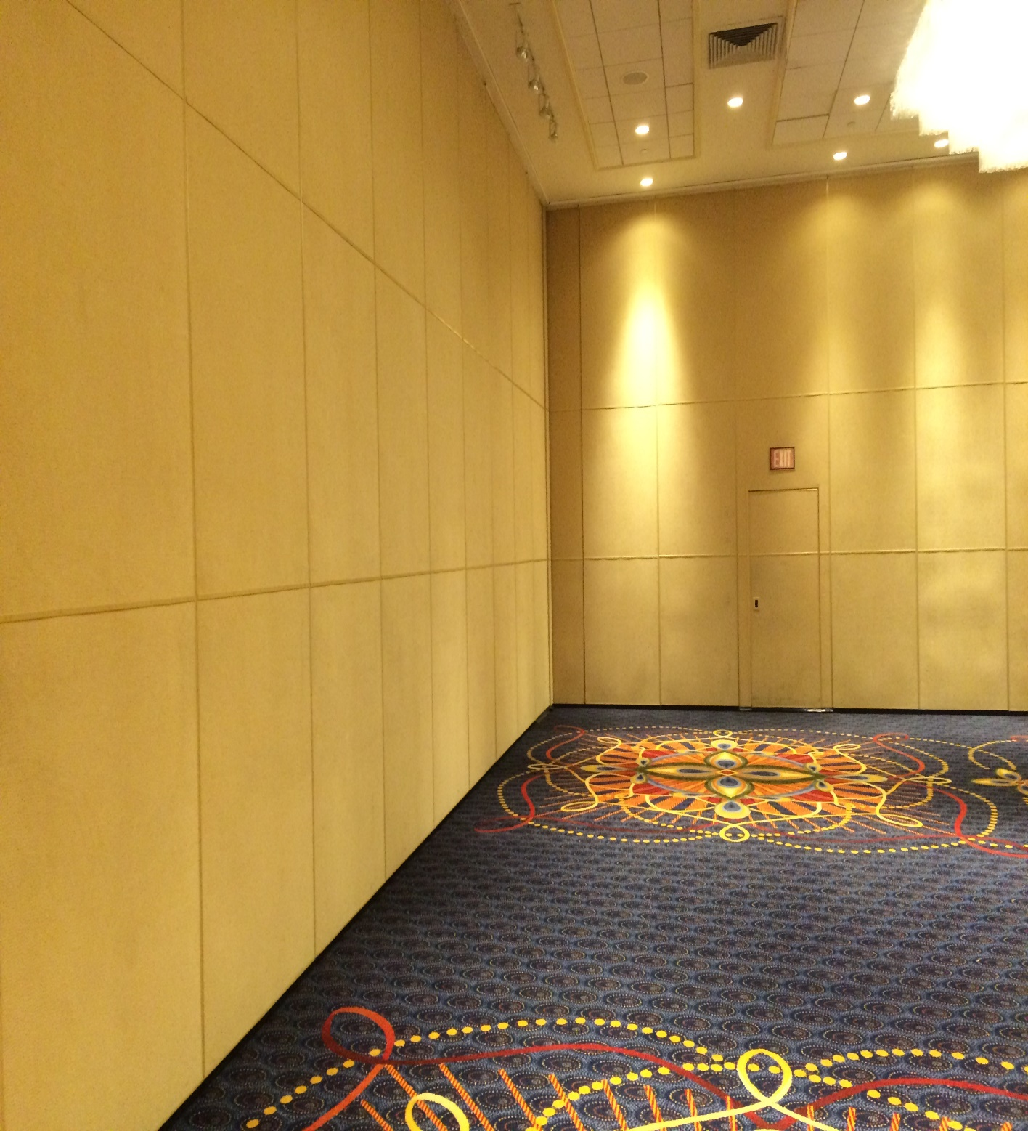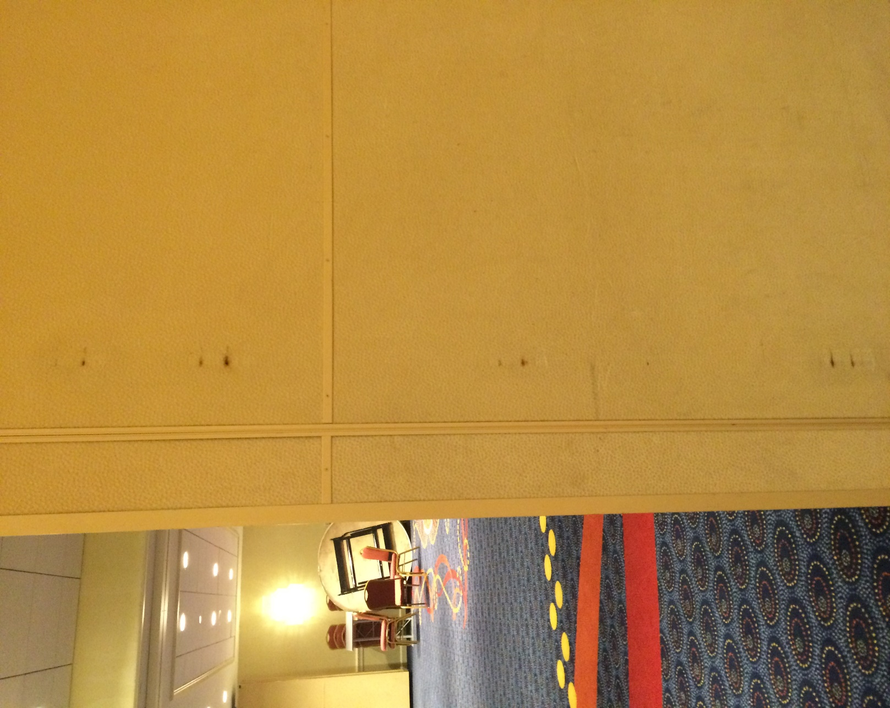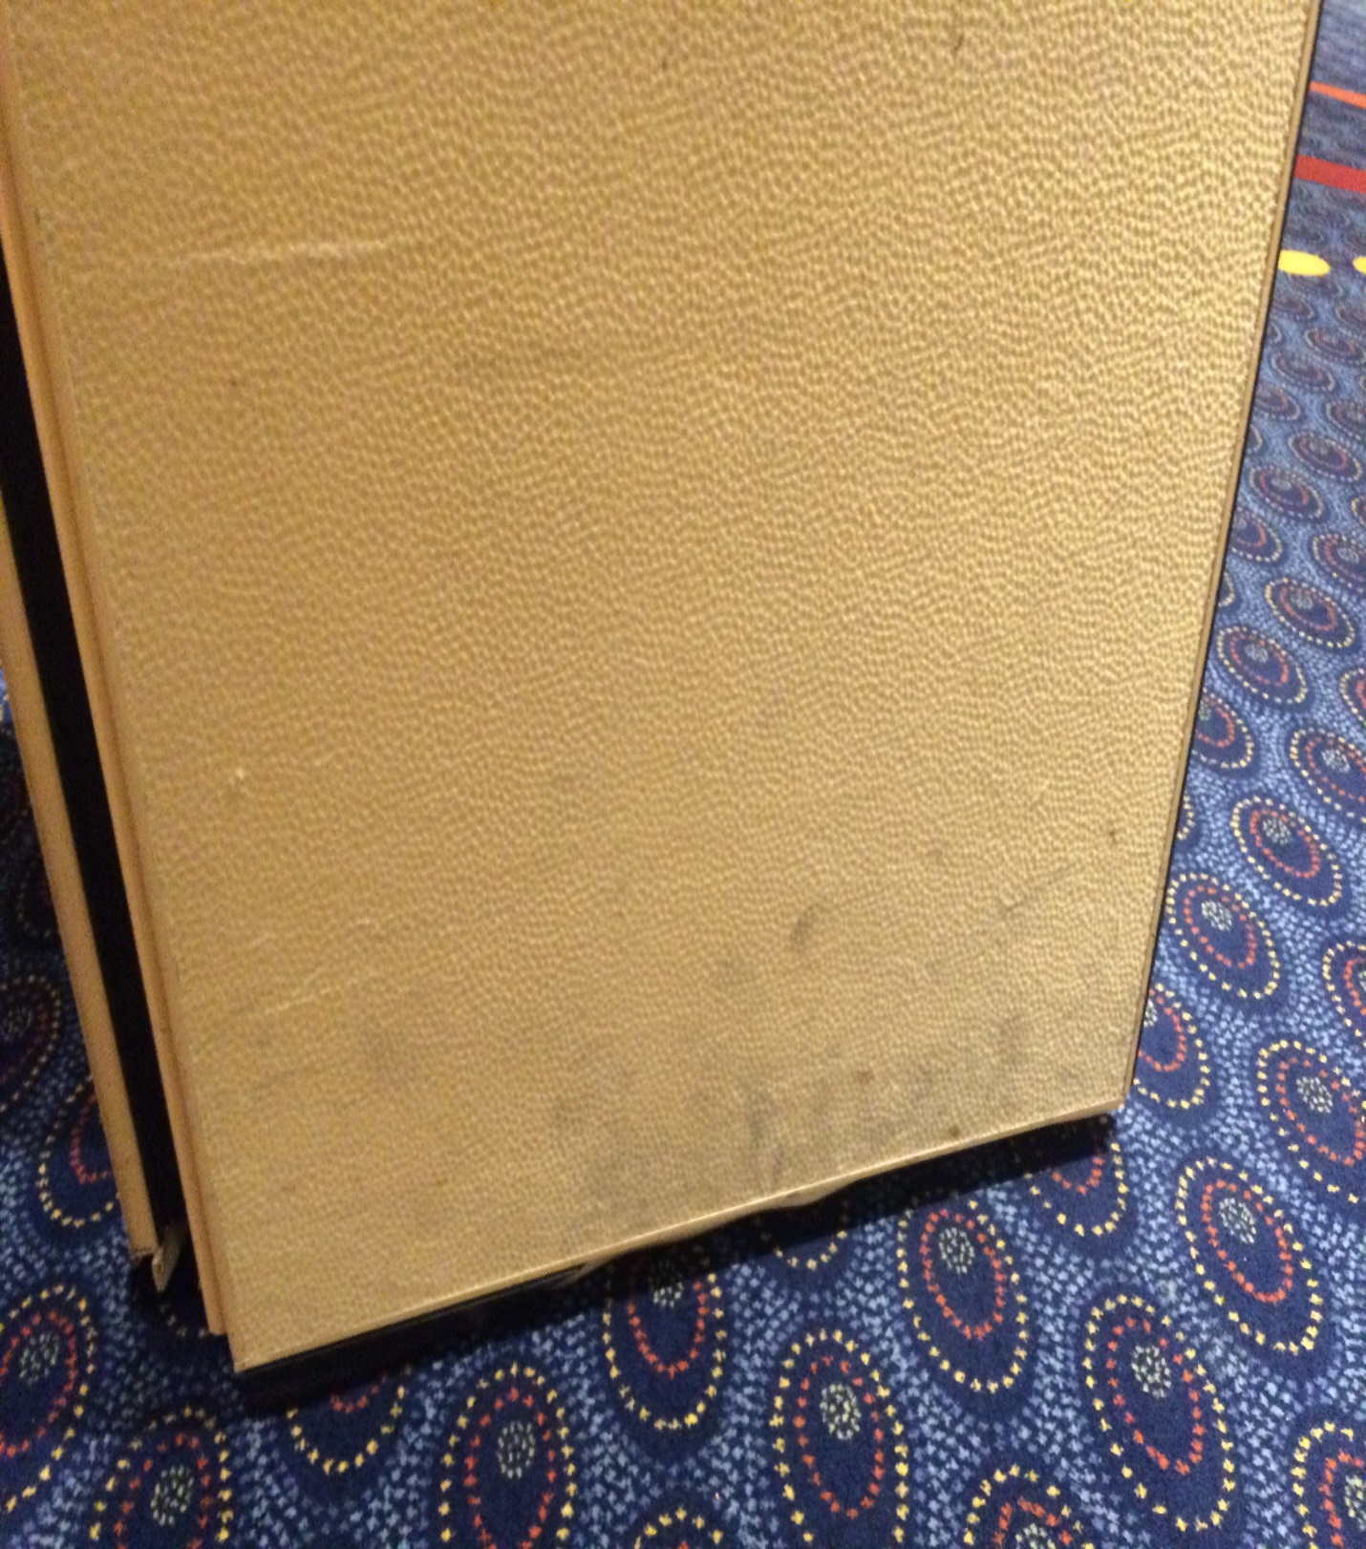

Now introducing our exclusive deep cleaning system for your venue…

Renue’s Rapid Venue Restoration

- INSPECTION: All panels are inspected to determine fiber consistency and overall condition of material. Most are made of synthetic blends that require a very special formulation of chemical and specific cleaning procedures. We also test clean and area to make sure for colorfastness.
- CHEMICAL: Chemical formulations are then constructed based on Fiber I.D. and if available, the manufactures’ specifications.
- PRESPOTTING: Panels are then pre-treated using Renue Systems’ exclusive soil release chemical.
- CLEANING: Material is cleaned with either hot water extraction (HWE), solvent sponges or cleaning pads, hand cleaning and buffing discs to remove the overall soil load.

Project details and costs for proposed cleaning

Panel / Air wall Cleaning

- All air walls in Oak Brook Ballroom…....……….$2,200.00
- 300 banquet chairs………………………………..$435.00

PLEASE NOTE:

*Hotel will provide us access to their scissor lift during cleaning.

*48 hour cancellation notice required or a 15% cancellation fee will be charged.

*Renue Systems requires a $375.00 minimum service call charge per visit.

*Hotel will provide complimentary parking during any scheduled work or cost will be billed back to the hotel.

Note some staining in the Air-Wall fibers may be permanent and not removable with cleaning

We will be glad to afford you billing considerations to work within your budget

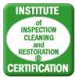

Please complete this service agreement, sign it and return it to your local National Appeal service provider.

Scope of Service:

Description: ________________________________________________________________

______________________________________________________________________________

Payment Terms:

The sum of $________________ is the agreed upon price for the services rendered with payment to made as follows:

____________ payments each for $___________ according to the following schedule:
______________________________________________________________________________

Please check here if your property will be paying by P-Card ___ or credit card ___

Card # _________________________ Card type _________________ Exp. date __________

Acceptance of Service Agreement

The above pricing, specifications, terms and conditions are satisfactory and you are hereby authorized to commence the work as specified.

Name: _______________________________________________ Property:__________________________________

Signature: ____________________________________________ P.O. # (if needed):___________________________

Title: ________________________________________________ Date: _____________________________________

Phone: _______________________________________________ Email: ____________________________________

